**University of Dhaka**



**Department of Computer Science and Engineering**

Project Report

“Race – Where It All Begins”

Submitted By –

Pritom Saha

Roll – 56

Submitted To -

Dr.Muahammad Asif Hossain Khan

Associate Professor, Dept. of CSE, DU

Ms. Anna Fariha

Lecturer, Dept. of CSE, DU

# Table Of Contents:

**1.Executive Summary** 3

**2. Objective** 3

**3. The Game** 3

**4. Rules** 4

**5. Patterns** 4

**6. Graphical User Interface** 5-11

**7. Flow Chart of the Game** 12

**8.** **User Defined Functions if the Game** 12-13

**9. Built-In Functions** 14-15

**10. Program Coding**…………..……….…………………………………………………………………16-49

**11. Header Used In The Code :**

**EnemyCars.h :**

**Car_My.h:** 50-67

**12. Limitations :** 68

**13. Constraints:** 68

**13. Conclusion::** 68

“Race – Where It All Begins”

**1. Executive Summary:**

Race - “Where It All Begins” is a game to be played by the players who wants only better graphics and better artwork. It is a 2D game, we used BGI library to build the game.

There are impressive artworks in different levels. The Players will love these artworks, especially the views beside the road! The graphics of the game isn’t up to the mark, because the utility is very old.

In different levels there are enemy-cars and some bonus enemy cars. If a player touches a car then it will lose scores. It is the kind of game which requires the skill of concentration as the player may require choosing his path wisely to avoid the enemies.

**2. Objective:**

The objective of this project was to create a game using the BGI library and the game chosen for a Car Racing game. The game was implemented in C/C++. The options to be made in the Main Menu were New Game, Instructions, High-Score and Credits. There are Exactly Eight Levels of the game.

**3. The Game:**

This game is played by a Red car. A car that will go on a journey which the player will never forget! A car that can move up, down, left, right. A car that can defy all the odds, all the obstacles that’s been put in front of it.

The enemy cars will want to end the player’s dream run, but the player will try to avoid the enemy cars. If it an enemy car touches the main Car, then the Car blasts and then the car is renewed by some antidote and that’s how the car will lose some scores. There are Eight lives.

So, the player has to be careful! Or the car will never end the journey!

**4. Rules:**

* The Car can only move in the four cardinal directions if there are free spaces in front of it. If the input direction is blocked by enemy-car, then the car will blast and lose points sequentially.
* If the car is hit by an enemy car, then the car will blast and then reincarnate. This will happen 8 times before the game is over!
* Each level will contain 60-80-90 points. With every 60 points the level will change! Going to level 8, then the increase of levels will stop. And the enemy cars will try to make your life a living hell!

**5. Patterns:**

If the player observes carefully he will notice certain patterns in the game. These are as below:

The Car turns into a various color car if it hits the Enemy car.

The Enemy cars will try to stop you from moving forward, you have to be aware of that fact!

The game can be restarted if the player runs out of life, which’s EIGHT.

The Player can also know who’s behind him and who’s ahead of him in the High-Score section.

**6. Graphical User Interface :**

Menu and Front page of the Game :

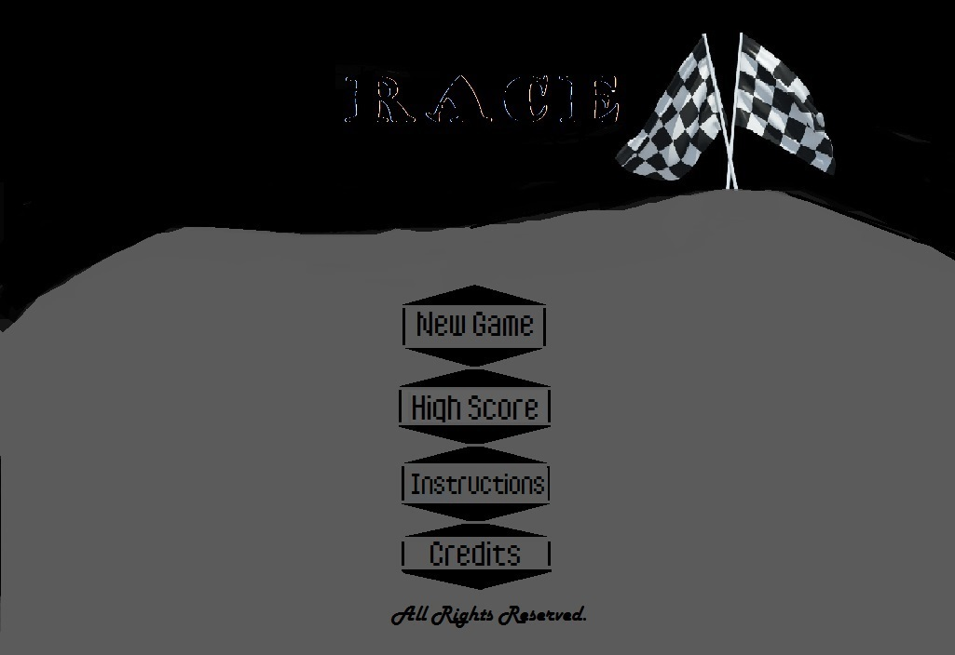

High Score section :



Instructions :

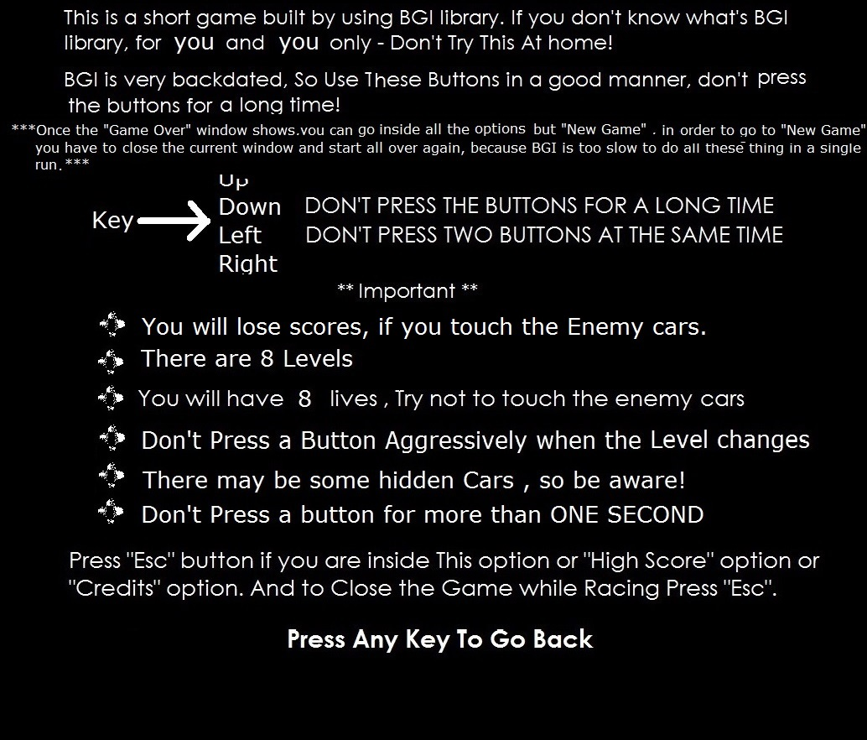

New Game :

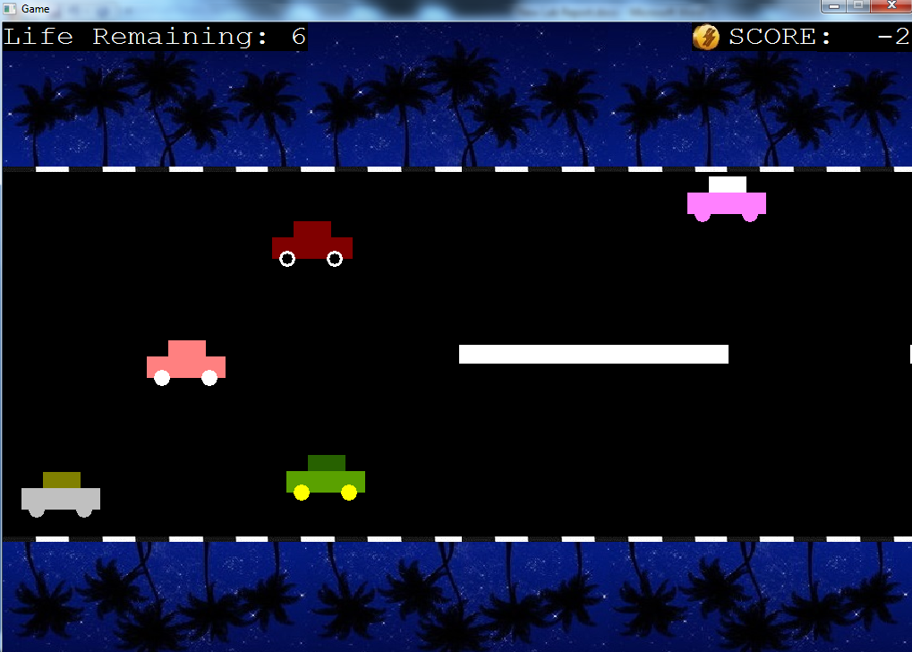

**Level -1 :**

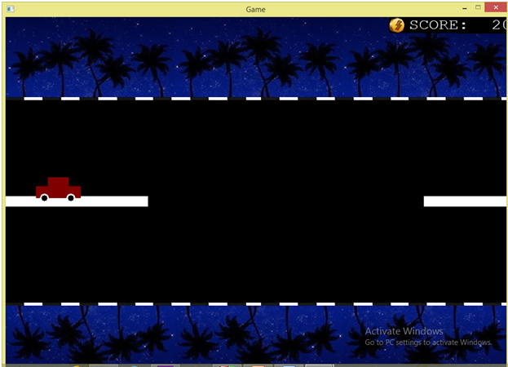

**Level 6 :**

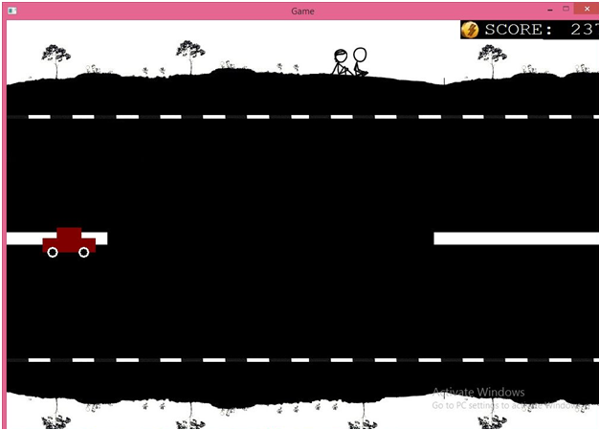

Credits :

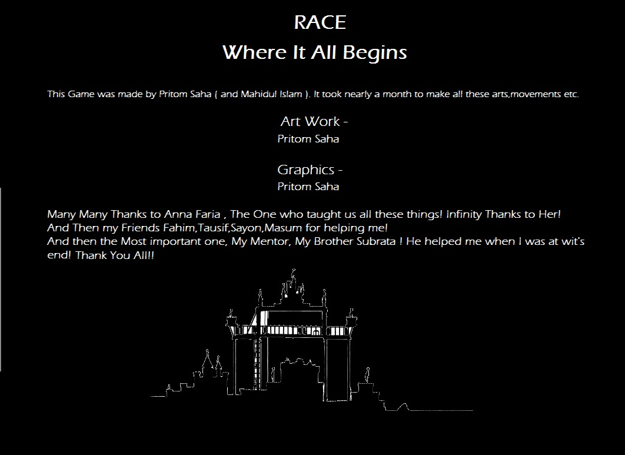

**7. Flow Chart of the Game –**

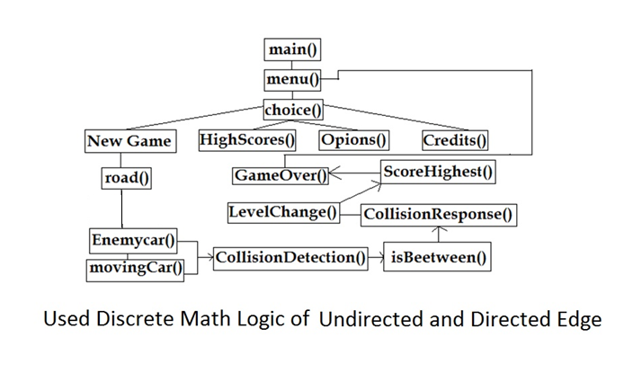

**8. User Defined Functions if the Game :**

1. int main() – Where it all Begins , The begins here!
2. void createMenu()– The Menu Stars here.
3. void choice1() – New Game Stars.
4. void choice2() – Shows High score.
5. void choice3() – Shows the instructions of the game , mainly how to play the game and the controls of the game.
6. void choice4() – shows you the Credits of the game.
7. void Upper(inta,intb,intc,int d) – shows the Images of the Grass, Sea, Hills of Upper Part of the window.
8. void Lower(inta,intb,intc,int d) – shows the Images of the Grass, Sea, Hills of LowerPart of the window.
9. voidMovingRoad() and void MovingRoad2() – Shows the white part of the road.
10. void Road() – The Pavement of the road.
11. void Score() – shows the Score constantly.
12. voidMovingScore() – The Original Score that changes.
13. void EnemyCarReInCarnated1() and void EnemyCarReInCarnated2() - Re assigns the values of the variables so that they can be used again and again!
14. voidEnemyCar() – Draws The Enemycar.
15. voidsortIfHighest() – Shows the High Score if the new one is higher than the previous ones.
16. voidCollisionDetection() – returns true(1) if the collision between the car and enemy car happens.
17. voidCollisionResponse() – what would happen after the collision , it is created to react to that collision.
18. voidLevelChange() – changes level if the score meets the required need!
19. void test() – Takes UserName Input.
20. void showHighScores() – Shows the High Score if the user wants to see the high scores of the game.
21. void Credits() – Shows the Credits of the game.
22. voidwriteToFile() – Immediately writes the username and score when the game ends.
23. voidgameOver() – Shows an image if the three lives are over.
24. boolisBetween() – detects if the car and the enemy car touches each other.
25. voidMoveTheRoad() – Moves Road.
26. void RoadReInCarnated1() and void RoadReInCarnated2() – Re assigns the values of the road variables.
27. void restart() – Restarts every variable if the game is restarted within the game.
28. voidEnemyCar() – This is where every part of the Enemy Car is drawn!
29. voidmyCar() – This is a Structure , where every part of the car is drawn.
30. voidMovingCar() – This is the main place where the Car moves.
31. void CarrReinCarnation1() and void CarrReinCarnation2() – A place to re assign the values of the car if the game restarts.
32. StructMyStruct{} – A structure used to sort the Points!
33. void EnemycarReincarnated – A function that re assigns the value of the enemy cars when they go off the screen.

**9. Built-In Functions –**

1. **void bar**(int left, int top, int right, int bottom) - bar draws a filled-in, rectangular, two-dimensional bar. The bar is filled using the current fill pattern and fill color. bar does not outline the bar; to draw an outlined two-dimensional bar, use bar3d with depth equal to 0.

The upper left and lower right corners of the rectangle are given by (left, top) and (right, bottom), respectively. The coordinates refer to pixels.

1. **void cleardevice**(void) - cleardevice erases (that is, fills with the current background color) the entire graphics screen and moves the

CP (current position) to home (0,0).

1. **void delay**(intmillisec) – The delay function is available in the winbgimimplementation of BGI graphics. You do not need to include conio.h; just include graphics.h. The function pauses the computation for the the specified number of milliseconds.
2. **void fillellipse**(int x, int y, intxradius, intyradius) - Draws an ellipse using (x,y) as a center point and xradius and yradius as the horizontal and vertical axes, and fills it with the current fill color and fill pattern.
3. **void circle**(int x, int y, int radius) - circle draws a circle in the current drawing color with its center at (x,y) and the radius given by radius.
4. **int getch**(void) - The getch function is available in the winbgimimplementation of BGI graphics. You do not need to include conio.h; just include graphics.h. The function reads one character from the keyboard and returns its ASCII value (without waiting for a return key). In order to work, the user must click in the graphics window (i.e., the Windows focus must be in the graphics window). For special keys, the getch function first returns ASCII 0. The next call will then return one of these special keys.
5. **void rectangle**(int left, int top, int right, int bottom) - rectangle draws a rectangle in the current line style, thickness, and drawing color. (left,top) is the upper left corner of the rectangle, and (right,bottom) is its lower right corner.
6. **void readimagefile**(const char* title=NULL,int left=0, int right=0, int right=INT_MAX, int bottom=INT_MAX) - The readimagefile function is available in the [winbgim](http://www.cs.colorado.edu/%7Emain/bgi/README.html) implementation of BGI graphics. You do not need to include conio.h; just include graphics.h. The function reads a BMP, GIF, JPG, ICO, EMF or WMF image file and displays it in part of the current active window. The filename may be NULL.
7. **void outtextxy**(int x, int y, char *textstring) - outtextxy displays a text string in the viewport at the given position (x, y), using the current justification settings and the current font, direction, and size.
8. **void setbkcolor**(int color) - setbkcolor sets the background to the color specified by color. The argument color can be a name or a number as listed below. (These symbolic names are defined in graphics.h.) .
9. **void setcolor**(int color) - setcolor sets the current drawing color to color, which can range from 0 to getmaxcolor. The current drawing color is the value to which pixels are set when lines, and so on are drawn. The drawing colors shown below are available for the CGA and EGA, respectively.

|  |
| --- |
|  |

1. **void setfillstyle**(int pattern, intcolor) - setfillstyle sets the current fill pattern and fill color. To set a user-defined fill pattern, do not give a pattern of 12 (USER_FILL) to setfillstyle; instead, call setfillpattern.
2. **void settextjustify**(inthoriz, intvert) - Text output after a call to settextjustify is justified around the current position (CP) horizontally and vertically, as specified. The default justification settings are LEFT_TEXT (for horizontal) and TOP_TEXT (for vertical). The enumeration text_just in graphics.h provides names for the horiz and vert settings passed to settextjustify.

|  |
| --- |
|  |

1. **void settextstyle**(int font, int direction, intcharsize) - settextstyle sets the text font, the direction in which text is displayed, and the size of the characters. A call to settextstyle affects all text output by outtext and outtextxy.

|  |
| --- |
|  |

**10. Program Coding:**

#include"graphics.h"

#include<time.h>

#include<stdlib.h>

#include "Car_My.h"

#include"EnemyCars.h"

#include<vector>

#include<algorithm>

using namespace std;

#define Window_X 1016

#define Window_Y 730

#define U_Grass_X1 0

#define U_Grass_Y1 0

#define U_Grass_X2 1016

#define U_Grass_Y2 740/3 - 55 - 25 // = 191

#define D_Grass_X1 0

#define D_Grass_Y1 740 - (740/3 - 55) + 25 // = 549

#define D_Grass_X2 1016

#define D_Grass_Y2 740

#define Road_X1 0

#define Road_Y1 740/3 - 55

#define Road_X2 1016

#define Road_Y2 740 - (740/3 - 55)

#define Road_Moving_X1 100

#define Road_Moving_Y1 360

#define Road_Moving_X2 400

#define Road_Moving_Y2 380

int road_moving_X1=Road_Moving_X1;

int road_moving_Y1=Road_Moving_Y1;

int road_moving_X2=Road_Moving_X2;

int road_moving_Y2=Road_Moving_Y2;

int road2_moving_X1=Road_Moving_X1+500;

int road2_moving_Y1=Road_Moving_Y1;

int road2_moving_X2=Road_Moving_X2+500;

int road2_moving_Y2=Road_Moving_Y2;

#define Sun_X 1000

#define Sun_Y 0

#define Sun_Rad 50

int Enemy_car_right_inner_x=R_Inner_Car_Wheel_X+1000; //Enemy Car Vaiables End

int Enemy_car_right_inner_y=R_Inner_Car_Wheel_Y-50;

int Enemy_car_right_inner_rad=R_Inner_Car_Wheel_Rad;

int Enemy_car_right_inner_color1=WHITE;

int Enemy_car_right_inner_color2=WHITE;

#define MAX_COLLISION_ALLOWED 8

//for Level(s)

int levelChange=0;

//for Score

int s11=0;

char scc[50];

//for Life

int life = MAX_COLLISION_ALLOWED;

char lif[50];

// car Struct

myCar car;

// for menu

int choice;

char userName[100];

//for game ove and then menu

int aks=0;

// level changing scores

#define FIRST_LEVEL_SCORE 60

#define SECOND_LEVEL_SCORE 120

#define THIRD_LEVEL_SCORE 180

#define FOURTH_LEVEL_SCORE 240

#define FIFTH_LEVEL_SCORE 300

#define SIXTH_LEVEL_SCORE 360

#define SEVENTH_LEVEL_SCORE 430

// for highscores

FILE *fout = fopen("highScores.txt","a");

struct MyStruct

{

int key;

char stringValue[100];

bool operator < (const MyStruct& str) const

{

return (str.key < key);

}

};

vector<MyStruct> sortCeleb;

//Declaration

void test();

void showHighScores();

void choice1();

void choice2();

void createMenu();

void sortIfHighest();

void gameOver();

void Credits();

void isBetween();

void INITIALIZE();

void ReinAllEnemy();

//Celebration

int max=-1;

void Upper(int a,int b,int c,int d)

{

readimagefile("palm.jpg",a,b,c,d); //Upper (U_Grass)

}

void Lower(int a,int b,int c,int d)

{

readimagefile("palmNight.jpg",a,b,c,d);

}

void MovingRoad(int a,int b,int c,int d,int e)

{

setcolor(e);

rectangle(a,b,c,d);

setfillstyle(SOLID_FILL,e);

bar(a,b,c,d);

}

void MovingRoad2(int a,int b,int c,int d,int e)

{

setcolor(e);

rectangle(a,b,c,d);

setfillstyle(SOLID_FILL,e);

bar(a,b,c,d);

}

void Road()

{

readimagefile("image004.jpg",U_Grass_X1,U_Grass_Y2-5,U_Grass_X2,U_Grass_Y2); //Pavement 1

readimagefile("image004.jpg",D_Grass_X1,D_Grass_Y1,D_Grass_X2,D_Grass_Y1+5); //Pavement 2

}

void RoadReincarnated1()

{

road_moving_X1=Road_Moving_X1+950;

road_moving_Y1=Road_Moving_Y1;

road_moving_X2=Road_Moving_X2+950;

road_moving_Y2=Road_Moving_Y2;

}

void RoadReincarnated2()

{

road2_moving_X1=Road_Moving_X1+950;

road2_moving_Y1=Road_Moving_Y1;

road2_moving_X2=Road_Moving_X2+950;

road2_moving_Y2=Road_Moving_Y2;

}

void MoveTheRoad(int speed,int color)

{

MovingRoad(road_moving_X1-=speed,road_moving_Y1,road_moving_X2-=speed,road_moving_Y2,color);

MovingRoad2(road2_moving_X1-=speed,road2_moving_Y1,road2_moving_X2-=speed,road2_moving_Y2,color);

}

void Enemy_Above_Part_Car(int a,int b,int c,int d,int color)

{

setcolor( color); //(Enemy Above Car)

rectangle(a,b,c,d);

setfillstyle(SOLID_FILL,color);

bar(a,b,c,d);

}

void Enemy_Down_Part_Car(int a,int b,int c,int d,int color)

{

setcolor(color); //(Down Car)

rectangle(a,b,c,d);

setfillstyle(SOLID_FILL,color);

bar(a,b,c,d);

}

void Enemy_Left_Wheel_Car(int a,int b,int c,int color)

{

setcolor(color); //Left Wheel

circle(a,b,c);

setfillstyle(SOLID_FILL,color);

fillellipse(a,b,c,c);

}

void Enemy_Right_Wheel_Car(int a,int b,int c,int color)

{

setcolor(color);

circle(a,b,c); //Right Wheel

setfillstyle(SOLID_FILL,color);

fillellipse(a,b,c,c);

}

void Enemy_Left_Inner_Wheel_Car(int a,int b,int c,int color)

{

setcolor(color); //Left Inner Wheel

circle(a,b,c);

setfillstyle(SOLID_FILL,color);

fillellipse(a,b,c,c);

}

void Enemy_Right_Inner_Wheel_Car(int a,int b,int c,int color)

{

setcolor(color);

circle(a,b,c); //Right Inner Wheel

setfillstyle(SOLID_FILL,color);

fillellipse(a,b,c,c);

}

bool isBetween(int a,int b,int c)

{

return a <= b && b<= c;

}

void EnemyCar(int EnemyColors[],int Speed)

{

Enemy_Above_Part_Car(Enemy_car_above_x1-=Speed,Enemy_car_above_y1,Enemy_car_above_x2-=Speed,Enemy_car_above_y2,EnemyColors[0]);

Enemy_Down_Part_Car(Enemy_car_down_x1-=Speed,Enemy_car_down_y1,Enemy_car_down_x2-=Speed,Enemy_car_down_y2,EnemyColors[1]);

Enemy_Left_Wheel_Car(Enemy_car_leftwh_x-=Speed,Enemy_car_leftwh_y,Enemy_car_leftwh_rad,EnemyColors[2]);

Enemy_Right_Wheel_Car(Enemy_car_rightwh_x-=Speed,Enemy_car_rightwh_y,Enemy_car_rightwh_rad,EnemyColors[3]);

Enemy_Left_Inner_Wheel_Car(Enemy_car_left_inner_x-=Speed,Enemy_car_left_inner_y,Enemy_car_left_inner_rad,EnemyColors[4]);

Enemy_Right_Inner_Wheel_Car(Enemy_car_right_inner_x-=Speed,Enemy_car_right_inner_y,Enemy_car_right_inner_rad,EnemyColors[5]);

}

void EnemyCar11(int EnemyColors[],int Speed)

{

Enemy_Above_Part_Car(Enemy_car11_above_x1-=Speed,Enemy_car11_above_y1,Enemy_car11_above_x2-=Speed,Enemy_car11_above_y2,EnemyColors[0]);

Enemy_Down_Part_Car(Enemy_car11_down_x1-=Speed,Enemy_car11_down_y1,Enemy_car11_down_x2-=Speed,Enemy_car11_down_y2,EnemyColors[1]);

Enemy_Left_Wheel_Car(Enemy_car11_leftwh_x-=Speed,Enemy_car11_leftwh_y,Enemy_car11_leftwh_rad,EnemyColors[2]);

Enemy_Right_Wheel_Car(Enemy_car11_rightwh_x-=Speed,Enemy_car11_rightwh_y,Enemy_car11_rightwh_rad,EnemyColors[3]);

}

void EnemyCar113(int EnemyColors[],int Speed)

{

Enemy_Above_Part_Car(Enemy_car113_above_x1-=Speed,Enemy_car113_above_y1,Enemy_car113_above_x2-=Speed,Enemy_car113_above_y2,EnemyColors[0]);

Enemy_Down_Part_Car(Enemy_car113_down_x1-=Speed,Enemy_car113_down_y1,Enemy_car113_down_x2-=Speed,Enemy_car113_down_y2,EnemyColors[1]);

Enemy_Left_Wheel_Car(Enemy_car113_leftwh_x-=Speed,Enemy_car113_leftwh_y,Enemy_car113_leftwh_rad,EnemyColors[2]);

Enemy_Right_Wheel_Car(Enemy_car113_rightwh_x-=Speed,Enemy_car113_rightwh_y,Enemy_car113_rightwh_rad,EnemyColors[3]);

}

void EnemyCar114(int EnemyColors[],int Speed)

{

Enemy_Above_Part_Car(Enemy_car114_above_x1-=Speed,Enemy_car114_above_y1,Enemy_car114_above_x2-=Speed,Enemy_car114_above_y2,EnemyColors[0]);

Enemy_Down_Part_Car(Enemy_car114_down_x1-=Speed,Enemy_car114_down_y1,Enemy_car114_down_x2-=Speed,Enemy_car114_down_y2,EnemyColors[1]);

Enemy_Left_Wheel_Car(Enemy_car114_leftwh_x-=Speed,Enemy_car114_leftwh_y,Enemy_car114_leftwh_rad,EnemyColors[2]);

Enemy_Right_Wheel_Car(Enemy_car114_rightwh_x-=Speed,Enemy_car114_rightwh_y,Enemy_car114_rightwh_rad,EnemyColors[3]);

}

void EnemyCar115(int EnemyColors[],int Speed)

{

Enemy_Above_Part_Car(Enemy_car115_above_x1-=Speed,Enemy_car115_above_y1,Enemy_car115_above_x2-=Speed,Enemy_car115_above_y2,EnemyColors[0]);

Enemy_Down_Part_Car(Enemy_car115_down_x1-=Speed,Enemy_car115_down_y1,Enemy_car115_down_x2-=Speed,Enemy_car115_down_y2,EnemyColors[1]);

Enemy_Left_Wheel_Car(Enemy_car115_leftwh_x-=Speed,Enemy_car115_leftwh_y,Enemy_car115_leftwh_rad,EnemyColors[2]);

Enemy_Right_Wheel_Car(Enemy_car115_rightwh_x-=Speed,Enemy_car115_rightwh_y,Enemy_car115_rightwh_rad,EnemyColors[3]);

}

void EnemyCar116(int EnemyColors[],int Speed)

{

Enemy_Above_Part_Car(Enemy_car116_above_x1-=Speed,Enemy_car116_above_y1,Enemy_car116_above_x2-=Speed,Enemy_car116_above_y2,EnemyColors[0]);

Enemy_Down_Part_Car(Enemy_car116_down_x1-=Speed,Enemy_car116_down_y1,Enemy_car116_down_x2-=Speed,Enemy_car116_down_y2,EnemyColors[1]);

Enemy_Left_Wheel_Car(Enemy_car116_leftwh_x-=Speed,Enemy_car116_leftwh_y,Enemy_car116_leftwh_rad,EnemyColors[2]);

Enemy_Right_Wheel_Car(Enemy_car116_rightwh_x-=Speed,Enemy_car116_rightwh_y,Enemy_car116_rightwh_rad,EnemyColors[3]);

}

void EnemyCar117(int EnemyColors[],int Speed)

{

Enemy_Above_Part_Car(Enemy_car117_above_x1-=Speed,Enemy_car117_above_y1,Enemy_car117_above_x2-=Speed,Enemy_car117_above_y2,EnemyColors[0]);

Enemy_Down_Part_Car(Enemy_car117_down_x1-=Speed,Enemy_car117_down_y1,Enemy_car117_down_x2-=Speed,Enemy_car117_down_y2,EnemyColors[1]);

Enemy_Left_Wheel_Car(Enemy_car117_leftwh_x-=Speed,Enemy_car117_leftwh_y,Enemy_car117_leftwh_rad,EnemyColors[2]);

Enemy_Right_Wheel_Car(Enemy_car117_rightwh_x-=Speed,Enemy_car117_rightwh_y,Enemy_car117_rightwh_rad,EnemyColors[3]);

}

void EnemyCar118(int EnemyColors[],int Speed)

{

Enemy_Above_Part_Car(Enemy_car118_above_x1-=Speed,Enemy_car118_above_y1,Enemy_car118_above_x2-=Speed,Enemy_car118_above_y2,EnemyColors[0]);

Enemy_Down_Part_Car(Enemy_car118_down_x1-=Speed,Enemy_car118_down_y1,Enemy_car118_down_x2-=Speed,Enemy_car118_down_y2,EnemyColors[1]);

Enemy_Left_Wheel_Car(Enemy_car118_leftwh_x-=Speed,Enemy_car118_leftwh_y,Enemy_car118_leftwh_rad,EnemyColors[2]);

Enemy_Right_Wheel_Car(Enemy_car118_rightwh_x-=Speed,Enemy_car118_rightwh_y,Enemy_car118_rightwh_rad,EnemyColors[3]);

}

void EnemyCarReIncarnated_1(int y_speed)

{

Enemy_car_above_x1=Car_Rectangle_X1+1000; //Enemy Car

Enemy_car_above_y1=Car_Rectangle_Y1-50+y_speed;

Enemy_car_above_x2=Car_Rectangle_X2+1000;

Enemy_car_above_y2=Car_Rectangle_Y2-50+y_speed;

Enemy_car_above_color=RED;

Enemy_car_down_x1=D_Car_Rectangle_X1+1000;

Enemy_car_down_y1=D_Car_Rectangle_Y1-50+y_speed;

Enemy_car_down_x2=D_Car_Rectangle_X2+1000;

Enemy_car_down_y2=D_Car_Rectangle_Y2-50+y_speed;

Enemy_car_down_color=RED;

Enemy_car_leftwh_x=L_Car_Wheel_X+1000;

Enemy_car_leftwh_y=L_Car_Wheel_Y-50+y_speed;

Enemy_car_leftwh_rad=L_Car_Wheel_Rad;

Enemy_car_leftwh_color1=WHITE;

Enemy_car_leftwh_color2=BLACK;

Enemy_car_rightwh_x=R_Car_Wheel_X+1000;

Enemy_car_rightwh_y=R_Car_Wheel_Y-50+y_speed;

Enemy_car_rightwh_rad=R_Car_Wheel_Rad;

Enemy_car_rightwh_color1=WHITE;

Enemy_car_rightwh_color2=BLACK;

Enemy_car_left_inner_x=L_Inner_Car_Wheel_X+1000;

Enemy_car_left_inner_y=L_Inner_Car_Wheel_Y-50+y_speed;

Enemy_car_left_inner_rad=L_Inner_Car_Wheel_Rad;

Enemy_car_left_inner_color1=WHITE;

Enemy_car_left_inner_color2=WHITE;

Enemy_car_right_inner_x=R_Inner_Car_Wheel_X+1000; //Enemy Car Vaiables End

Enemy_car_right_inner_y=R_Inner_Car_Wheel_Y-50+y_speed;

Enemy_car_right_inner_rad=R_Inner_Car_Wheel_Rad;

Enemy_car_right_inner_color1=WHITE;

Enemy_car_right_inner_color2=WHITE;

}

void EnemyCarReIncarnated_2(int y_speed)

{

Enemy_car_above_x1=Car_Rectangle_X1+1000; //Enemy Car

Enemy_car_above_y1=Car_Rectangle_Y1+100+y_speed;

Enemy_car_above_x2=Car_Rectangle_X2+1000;

Enemy_car_above_y2=Car_Rectangle_Y2+100+y_speed;

Enemy_car_above_color=RED;

Enemy_car_down_x1=D_Car_Rectangle_X1+1000;

Enemy_car_down_y1=D_Car_Rectangle_Y1+100+y_speed;

Enemy_car_down_x2=D_Car_Rectangle_X2+1000;

Enemy_car_down_y2=D_Car_Rectangle_Y2+100+y_speed;

Enemy_car_down_color=RED;

Enemy_car_leftwh_x=L_Car_Wheel_X+1000;

Enemy_car_leftwh_y=L_Car_Wheel_Y+100+y_speed;

Enemy_car_leftwh_rad=L_Car_Wheel_Rad;

Enemy_car_leftwh_color1=WHITE;

Enemy_car_leftwh_color2=BLACK;

Enemy_car_rightwh_x=R_Car_Wheel_X+1000;

Enemy_car_rightwh_y=R_Car_Wheel_Y+100+y_speed;

Enemy_car_rightwh_rad=R_Car_Wheel_Rad;

Enemy_car_rightwh_color1=WHITE;

Enemy_car_rightwh_color2=BLACK;

Enemy_car_left_inner_x=L_Inner_Car_Wheel_X+1000;

Enemy_car_left_inner_y=L_Inner_Car_Wheel_Y+100+y_speed;

Enemy_car_left_inner_rad=L_Inner_Car_Wheel_Rad;

Enemy_car_left_inner_color1=WHITE;

Enemy_car_left_inner_color2=WHITE;

Enemy_car_right_inner_x=R_Inner_Car_Wheel_X+1000; //Enemy Car Vaiables End

Enemy_car_right_inner_y=R_Inner_Car_Wheel_Y+100+y_speed;

Enemy_car_right_inner_rad=R_Inner_Car_Wheel_Rad;

Enemy_car_right_inner_color1=WHITE;

Enemy_car_right_inner_color2=WHITE;

}

void sortIfHighest()

{

FILE *fifH = fopen("highScores.txt","r");

char user[101];

int score,max=-1;

while(fscanf(fifH,"%s %d",user,&score) !=-1)

{

MyStruct myStruct;

myStruct.key = score;

sortCeleb.push_back(myStruct);

if(max<score)

max=score;

}

sort(sortCeleb.begin(),sortCeleb.end());

printf("max = %d\n\n\n\n",max);

printf("s11 = %d\n\n\n",s11);

if(s11>=max)

{

cleardevice();

readimagefile("new-record-top.jpg",0,0,1016,300);

setcolor(WHITE);

settextstyle(COMPLEX_FONT,HORIZ_DIR,5);

settextjustify(CENTER_TEXT,CENTER_TEXT);

outtextxy(508,193+120,"ConGratulations!");

settextstyle(COMPLEX_FONT,HORIZ_DIR,5);

settextjustify(CENTER_TEXT,CENTER_TEXT);

outtextxy(508,193+180,userName);

settextstyle(COMPLEX_FONT,HORIZ_DIR,5);

settextjustify(CENTER_TEXT,CENTER_TEXT);

outtextxy(508,193+240,"You Are Now The Highest Scorer!");

getch();

delay(3000);

}

}

void Score()

{

setcolor(BLACK);

rectangle(770,0,822,31);

setfillstyle(SOLID_FILL,BLACK);

bar(770,0,822,31);

readimagefile("coins.jpg",770,0,802,31);

setcolor(BLACK);

rectangle(910,0,1016,32);

setfillstyle(SOLID_FILL,BLACK);

bar(910,0,1016,32);

setcolor(WHITE);

settextstyle(COMPLEX_FONT,HORIZ_DIR,15);

settextjustify(RIGHT_TEXT,BOTTOM_TEXT);

outtextxy(930,32,"SCORE:");

setcolor(BLACK);

rectangle(0,0,300,31);

setfillstyle(SOLID_FILL,BLACK);

bar(0,0,300,31);

setcolor(WHITE);

settextstyle(COMPLEX_FONT,HORIZ_DIR,15);

settextjustify(RIGHT_TEXT,BOTTOM_TEXT);

outtextxy(300,32,"Life Remaining:");

}

void MovingScore()

{

if(Enemy_car_down_x2<=0 )

{

s11+=(10-levelChange);

}

setcolor(WHITE);

settextstyle(COMPLEX_FONT,HORIZ_DIR,15);

settextjustify(RIGHT_TEXT,BOTTOM_TEXT);

sprintf(scc,"%d",s11);

outtextxy(1016,32,scc);

sprintf(lif,"%d",life);

outtextxy(340,32,lif);

if(life<10)

{

setcolor(BLACK);

rectangle(300,0,320,31);

setfillstyle(SOLID_FILL,BLACK);

bar(300,0,320,31);

}

}

bool CollisionDetection()

{

if(Enemy_car_above_x1 <= car.car_down_x2)

{

if(isBetween(car.car_down_y1,Enemy_car_above_y1,car.car_down_y2)==true

||isBetween(car.car_down_y1,Enemy_car_above_y2,car.car_down_y2)==true)

{

if(car.car_down_x1 <= Enemy_car_down_x2 )

{

return true;

}

}

}

if((Enemy_car_down_x1 <= car.car_above_x2) || (Enemy_car_down_x1 <= car.car_down_x2))

{

if((isBetween(car.car_above_y1,Enemy_car_down_y1,car.car_above_y2)==true

|| isBetween(car.car_above_y1,Enemy_car_down_y2,car.car_above_y2)==true)

|| (isBetween(car.car_down_y1,Enemy_car_down_y1,car.car_down_y2)==true

|| (isBetween(car.car_above_y1,Enemy_car_down_y2,car.car_above_y2)==true) ))

{

if(car.car_down_x1 <= Enemy_car_down_x2 )

{

return true;

}

}

}

return false;

}

bool CollisionDetection1()

{

if(Enemy_car11_above_x1 <= car.car_down_x2)

{

if(isBetween(car.car_down_y1,Enemy_car11_above_y1,car.car_down_y2)==true

||isBetween(car.car_down_y1,Enemy_car11_above_y2,car.car_down_y2)==true)

{

if(car.car_down_x1 <= Enemy_car11_down_x2 )

{

return true;

}

}

}

if((Enemy_car11_down_x1 <= car.car_above_x2) || (Enemy_car11_down_x1 <= car.car_down_x2))

{

if((isBetween(car.car_above_y1,Enemy_car11_down_y1,car.car_above_y2)==true

|| isBetween(car.car_above_y1,Enemy_car11_down_y2,car.car_above_y2)==true)

|| (isBetween(car.car_down_y1,Enemy_car11_down_y1,car.car_down_y2)==true

|| (isBetween(car.car_above_y1,Enemy_car11_down_y2,car.car_above_y2)==true) ))

{

if(car.car_down_x1 <= Enemy_car11_down_x2 )

{

return true;

}

}

}

return false;

}

bool CollisionDetection2()

{

if(Enemy_car113_above_x1 <= car.car_down_x2)

{

if(isBetween(car.car_down_y1,Enemy_car113_above_y1,car.car_down_y2)==true

||isBetween(car.car_down_y1,Enemy_car113_above_y2,car.car_down_y2)==true)

{

if(car.car_down_x1 <= Enemy_car113_down_x2 )

{

return true;

}

}

}

if((Enemy_car113_down_x1 <= car.car_above_x2) || (Enemy_car113_down_x1 <= car.car_down_x2))

{

if((isBetween(car.car_above_y1,Enemy_car113_down_y1,car.car_above_y2)==true

|| isBetween(car.car_above_y1,Enemy_car113_down_y2,car.car_above_y2)==true)

|| (isBetween(car.car_down_y1,Enemy_car113_down_y1,car.car_down_y2)==true

|| (isBetween(car.car_above_y1,Enemy_car113_down_y2,car.car_above_y2)==true) ))

{

if(car.car_down_x1 <= Enemy_car113_down_x2 )

{

return true;

}

}

}

return false;

}

bool CollisionDetection3()

{

if(Enemy_car114_above_x1 <= car.car_down_x2)

{

if(isBetween(car.car_down_y1,Enemy_car114_above_y1,car.car_down_y2)==true

||isBetween(car.car_down_y1,Enemy_car114_above_y2,car.car_down_y2)==true)

{

if(car.car_down_x1 <= Enemy_car114_down_x2 )

{

return true;

}

}

}

if((Enemy_car114_down_x1 <= car.car_above_x2) || (Enemy_car114_down_x1 <= car.car_down_x2))

{

if((isBetween(car.car_above_y1,Enemy_car114_down_y1,car.car_above_y2)==true

|| isBetween(car.car_above_y1,Enemy_car114_down_y2,car.car_above_y2)==true)

|| (isBetween(car.car_down_y1,Enemy_car114_down_y1,car.car_down_y2)==true

|| (isBetween(car.car_above_y1,Enemy_car114_down_y2,car.car_above_y2)==true) ))

{

if(car.car_down_x1 <= Enemy_car114_down_x2 )

{

return true;

}

}

}

return false;

}

bool CollisionDetection4()

{

if(Enemy_car115_above_x1 <= car.car_down_x2)

{

if(isBetween(car.car_down_y1,Enemy_car115_above_y1,car.car_down_y2)==true

||isBetween(car.car_down_y1,Enemy_car115_above_y2,car.car_down_y2)==true)

{

if(car.car_down_x1 <= Enemy_car115_down_x2 )

{

return true;

}

}

}

if((Enemy_car115_down_x1 <= car.car_above_x2) || (Enemy_car115_down_x1 <= car.car_down_x2))

{

if((isBetween(car.car_above_y1,Enemy_car115_down_y1,car.car_above_y2)==true

|| isBetween(car.car_above_y1,Enemy_car115_down_y2,car.car_above_y2)==true)

|| (isBetween(car.car_down_y1,Enemy_car115_down_y1,car.car_down_y2)==true

|| (isBetween(car.car_above_y1,Enemy_car115_down_y2,car.car_above_y2)==true) ))

{

if(car.car_down_x1 <= Enemy_car115_down_x2 )

{

return true;

}

}

}

return false;

}

bool CollisionDetection5()

{

if(Enemy_car116_above_x1 <= car.car_down_x2)

{

if(isBetween(car.car_down_y1,Enemy_car116_above_y1,car.car_down_y2)==true

||isBetween(car.car_down_y1,Enemy_car116_above_y2,car.car_down_y2)==true)

{

if(car.car_down_x1 <= Enemy_car116_down_x2 )

{

return true;

}

}

}

if((Enemy_car116_down_x1 <= car.car_above_x2) || (Enemy_car116_down_x1 <= car.car_down_x2))

{

if((isBetween(car.car_above_y1,Enemy_car116_down_y1,car.car_above_y2)==true

|| isBetween(car.car_above_y1,Enemy_car116_down_y2,car.car_above_y2)==true)

|| (isBetween(car.car_down_y1,Enemy_car116_down_y1,car.car_down_y2)==true

|| (isBetween(car.car_above_y1,Enemy_car116_down_y2,car.car_above_y2)==true) ))

{

if(car.car_down_x1 <= Enemy_car116_down_x2 )

{

return true;

}

}

}

return false;

}

bool CollisionDetection6()

{

if(Enemy_car117_above_x1 <= car.car_down_x2)

{

if(isBetween(car.car_down_y1,Enemy_car117_above_y1,car.car_down_y2)==true

||isBetween(car.car_down_y1,Enemy_car117_above_y2,car.car_down_y2)==true)

{

if(car.car_down_x1 <= Enemy_car117_down_x2 )

{

return true;

}

}

}

if((Enemy_car117_down_x1 <= car.car_above_x2) || (Enemy_car117_down_x1 <= car.car_down_x2))

{

if((isBetween(car.car_above_y1,Enemy_car117_down_y1,car.car_above_y2)==true

|| isBetween(car.car_above_y1,Enemy_car117_down_y2,car.car_above_y2)==true)

|| (isBetween(car.car_down_y1,Enemy_car117_down_y1,car.car_down_y2)==true

|| (isBetween(car.car_above_y1,Enemy_car117_down_y2,car.car_above_y2)==true) ))

{

if(car.car_down_x1 <= Enemy_car117_down_x2 )

{

return true;

}

}

}

return false;

}

bool CollisionDetection7()

{

if(Enemy_car118_above_x1 <= car.car_down_x2)

{

if(isBetween(car.car_down_y1,Enemy_car118_above_y1,car.car_down_y2)==true

||isBetween(car.car_down_y1,Enemy_car118_above_y2,car.car_down_y2)==true)

{

if(car.car_down_x1 <= Enemy_car118_down_x2 )

{

return true;

}

}

}

if((Enemy_car118_down_x1 <= car.car_above_x2) || (Enemy_car118_down_x1 <= car.car_down_x2))

{

if((isBetween(car.car_above_y1,Enemy_car118_down_y1,car.car_above_y2)==true

|| isBetween(car.car_above_y1,Enemy_car118_down_y2,car.car_above_y2)==true)

|| (isBetween(car.car_down_y1,Enemy_car118_down_y1,car.car_down_y2)==true

|| (isBetween(car.car_above_y1,Enemy_car118_down_y2,car.car_above_y2)==true) ))

{

if(car.car_down_x1 <= Enemy_car118_down_x2 )

{

return true;

}

}

}

return false;

}

void gameOver()

{

aks++;

levelChange=0;

sortIfHighest();

readimagefile("Game over.jpg",0,0,1016,730);

delay(4000);

createMenu();

}

void writeToFile()

{

FILE *fout = fopen("highScores.txt","a");

fprintf(fout,userName);

fprintf(fout," ");

fprintf(fout,"%d\n",s11);

fclose(fout);

}

void CollisionResponse(int count)

{

int i;

s11 -= (10-levelChange-1);

for(i=0;i<=45;i++)

{

car.Carr(i%16);

delay(10);

}

car.Carr(0);

if(car.car_above_y2>=382)

{

life--;

car.CarrReinCarnation1();

}

else

{

life--;

car.CarrReinCarnation2();

}

if(count == MAX_COLLISION_ALLOWED)

{

char strScore[100];

char userScore [100];

writeToFile();

gameOver();

}

}

void LevelChange()

{

if(levelChange==0)

{

if(s11>=FIRST_LEVEL_SCORE)

{

ReinAllEnemy();

cleardevice();

readimagefile("Checkered20flag.jpg",0,0,1016,730);

getch();

delay(2000);

cleardevice();

readimagefile("402313.jpg",U_Grass_X1,U_Grass_Y1,U_Grass_X2,U_Grass_Y2); //Upper (U_Grass)

readimagefile("402314.jpg",D_Grass_X1,D_Grass_Y1,D_Grass_X2,D_Grass_Y2);

Score();

Road();

levelChange++;

}

}

if(levelChange==1)

{

if(s11>=SECOND_LEVEL_SCORE)

{

ReinAllEnemy();

cleardevice();

readimagefile("l3.jpg",0,0,1016,730);

getch();

delay(2000);

cleardevice();

readimagefile("canvas-particle-2.jpg",U_Grass_X1,U_Grass_Y1,U_Grass_X2,U_Grass_Y2); //Upper (U_Grass)

readimagefile("canvas-particle-3.jpg",D_Grass_X1,D_Grass_Y1,D_Grass_X2,D_Grass_Y2);

Score();

Road();

levelChange++;

}

}

if(levelChange==2)

{

if(s11>=THIRD_LEVEL_SCORE)

{

ReinAllEnemy();

cleardevice();

readimagefile("asdd.jpg",0,0,1016,730);

getch();

delay(2000);

cleardevice();

readimagefile("1 layer.jpg",U_Grass_X1,U_Grass_Y1,U_Grass_X2,U_Grass_Y2); //Upper (U_Grass)

readimagefile("eletree-grass.jpg",D_Grass_X1,D_Grass_Y1,D_Grass_X2,D_Grass_Y2);

Score();

Road();

levelChange++;

}

}

if(levelChange==3)

{

if(s11>=FOURTH_LEVEL_SCORE)

{

ReinAllEnemy();

cleardevice();

readimagefile("5hhj.jpg",0,0,1016,730);

getch();

delay(2000);

cleardevice();

readimagefile("cartoon-land-4.jpg",U_Grass_X1,U_Grass_Y1,U_Grass_X2,U_Grass_Y2); //Upper (U_Grass)

readimagefile("cartoon-land-5.jpg",D_Grass_X1,D_Grass_Y1,D_Grass_X2,D_Grass_Y2);

Score();

Road();

levelChange++;

}

}

if(levelChange==4)

{

if(s11>=FIFTH_LEVEL_SCORE)

{

ReinAllEnemy();

cleardevice();

readimagefile("65gf.jpg",0,0,1016,730);

getch();

delay(2000);

cleardevice();

readimagefile("time-animated.jpg",U_Grass_X1,U_Grass_Y1,U_Grass_X2,U_Grass_Y2); //Upper (U_Grass)

readimagefile("time-animated2.jpg",D_Grass_X1,D_Grass_Y1,D_Grass_X2,D_Grass_Y2);

Score();

Road();

levelChange++;

}

}

if(levelChange==5)

{

if(s11>=SIXTH_LEVEL_SCORE)

{

ReinAllEnemy();

cleardevice();

readimagefile("7ghg.jpg",0,0,1016,730);

getch();

delay(2000);

cleardevice();

readimagefile("grassLAnd.jpg",U_Grass_X1,U_Grass_Y1,U_Grass_X2,U_Grass_Y2); //Upper (U_Grass)

readimagefile("grassLAnd11.jpg",D_Grass_X1,D_Grass_Y1,D_Grass_X2,D_Grass_Y2);

Score();

Road();

levelChange++;

}

}

if(levelChange==6)

{

if(s11>=SEVENTH_LEVEL_SCORE)

{

ReinAllEnemy();

cleardevice();

readimagefile("8.jpg",0,0,1016,730);

getch();

delay(2000);

cleardevice();

readimagefile("1last.jpg",U_Grass_X1,U_Grass_Y1,U_Grass_X2,U_Grass_Y2); //Upper (U_Grass)

readimagefile("last.jpg",D_Grass_X1,D_Grass_Y1,D_Grass_X2,D_Grass_Y2);

Score();

Road();

levelChange++;

}

}

}

void test()

{

cleardevice();

setcolor(WHITE);

settextstyle(COMPLEX_FONT,HORIZ_DIR,2);

settextjustify(LEFT_TEXT,TOP_TEXT);

outtextxy(85,50,"Please Don't Use BackSpace or Escape Button While Writting Your Name...");

setcolor(WHITE);

settextstyle(COMPLEX_FONT,HORIZ_DIR,3);

settextjustify(LEFT_TEXT,TOP_TEXT);

outtextxy(250,320,"Please Enter Your Name : ");

int i = 0;

setcolor(WHITE);

settextstyle(COMPLEX_FONT,HORIZ_DIR,3);

while(true)

{

char ch = getch();

if(ch == 13)

{

break;

}

if(ch == 8)

{

userName[--i] = '\0';

}

else

{

userName[i++] = ch;

userName[i] = '\0';

outtextxy(624,320,userName);

}

}

userName[i++] = ' ';

userName[i] = '\0';

}

char user[101];

int score;

void showHighScores()

{

vector<MyStruct> vHighScores;

FILE *fin = fopen("highScores.txt","r");

int row = 193;

char destBuf[100];

while(fscanf(fin,"%s %d",user,&score) !=-1)

{

printf("%s\t%d\n",user,score);

MyStruct myStruct;

myStruct.key = score;

strcpy(myStruct.stringValue,user);

vHighScores.push_back(myStruct);

}

if(choice==2)

{

sort(vHighScores.begin(), vHighScores.end());

int i;

cleardevice();

readimagefile("highscore1.jpg",0,0,1016,192);

for(i=0;i<vHighScores.size();i++)

{

MyStruct tempStruct = vHighScores[i];

setcolor(WHITE);

settextstyle(COMPLEX_FONT,HORIZ_DIR,3);

settextjustify(CENTER_TEXT,CENTER_TEXT);

outtextxy(385,row+12,tempStruct.stringValue);

setcolor(WHITE);

settextstyle(COMPLEX_FONT,HORIZ_DIR,3);

settextjustify(CENTER_TEXT,CENTER_TEXT);

outtextxy(620,row+12,itoa(tempStruct.key,destBuf,10));

row += 40;

}

getch();

fclose(fin);

cleardevice();

}

delay(100);

}

int getRandomColorCode()

{

srand(time(NULL));

return (1 + (rand() % 15));

}

void pushRandomColorsIntoArray(int *colorArray)

{

int i;

for(i=1;i<6;i++){

colorArray[i] = getRandomColorCode();

}

}

void ReinAllEnemy()

{

Enemy_car113_above_x1=Car_Rectangle_X1+1280; //Enemy Car

Enemy_car113_above_y1=Car_Rectangle_Y1 -40-50;

Enemy_car113_above_x2=Car_Rectangle_X2+1280;

Enemy_car113_above_y2=Car_Rectangle_Y2 -40-50;

Enemy_car113_above_color=RED;

Enemy_car113_down_x1=D_Car_Rectangle_X1+1280;

Enemy_car113_down_y1=D_Car_Rectangle_Y1-40-50;

Enemy_car113_down_x2=D_Car_Rectangle_X2+1280;

Enemy_car113_down_y2=D_Car_Rectangle_Y2-40-50;

Enemy_car113_down_color=RED;

Enemy_car113_leftwh_x=L_Car_Wheel_X+1280;

Enemy_car113_leftwh_y=L_Car_Wheel_Y-40-50;

Enemy_car113_leftwh_rad=L_Car_Wheel_Rad;

Enemy_car113_leftwh_color1=WHITE;

Enemy_car113_leftwh_color2=BLACK;

Enemy_car113_rightwh_x=R_Car_Wheel_X+1280;

Enemy_car113_rightwh_y=R_Car_Wheel_Y-40-50;

Enemy_car113_rightwh_rad=R_Car_Wheel_Rad;

Enemy_car113_rightwh_color1=WHITE;

Enemy_car113_rightwh_color2=BLACK;

Enemy_car113_left_inner_x=L_Inner_Car_Wheel_X+1280;

Enemy_car113_left_inner_y=L_Inner_Car_Wheel_Y-40-50;

Enemy_car113_left_inner_rad=L_Inner_Car_Wheel_Rad;

Enemy_car113_left_inner_color1=WHITE;

Enemy_car113_left_inner_color2=WHITE;

Enemy_car115_above_x1=Car_Rectangle_X1+1400; //Enemy Car

Enemy_car115_above_y1=Car_Rectangle_Y1-40-50+330;

Enemy_car115_above_x2=Car_Rectangle_X2+1400;

Enemy_car115_above_y2=Car_Rectangle_Y2-40-50+330;

Enemy_car115_above_color=RED;

Enemy_car115_down_x1=D_Car_Rectangle_X1+1400;

Enemy_car115_down_y1=D_Car_Rectangle_Y1-40-50+330;

Enemy_car115_down_x2=D_Car_Rectangle_X2+1400;

Enemy_car115_down_y2=D_Car_Rectangle_Y2-40-50+330;

Enemy_car115_down_color=RED;

Enemy_car115_leftwh_x=L_Car_Wheel_X+1400;

Enemy_car115_leftwh_y=L_Car_Wheel_Y-40-50+330;

Enemy_car115_leftwh_rad=L_Car_Wheel_Rad;

Enemy_car115_leftwh_color1=WHITE;

Enemy_car115_leftwh_color2=BLACK;

Enemy_car115_rightwh_x=R_Car_Wheel_X+1400;

Enemy_car115_rightwh_y=R_Car_Wheel_Y-40-50+330;

Enemy_car115_rightwh_rad=R_Car_Wheel_Rad;

Enemy_car115_rightwh_color1=WHITE;

Enemy_car115_rightwh_color2=BLACK;

Enemy_car115_left_inner_x=L_Inner_Car_Wheel_X+1400;

Enemy_car115_left_inner_y=L_Inner_Car_Wheel_Y-40-50+330;

Enemy_car115_left_inner_rad=L_Inner_Car_Wheel_Rad;

Enemy_car115_left_inner_color1=WHITE;

Enemy_car115_left_inner_color2=WHITE;

int inc1 = getRandomSign() * getRandomPositionWithinRange(1,100);

Enemy_car117_above_x1=Car_Rectangle_X1+1200; //Enemy Car

Enemy_car117_above_y1=Car_Rectangle_Y1+160+inc1;

Enemy_car117_above_x2=Car_Rectangle_X2+1200;

Enemy_car117_above_y2=Car_Rectangle_Y2+160+inc1;

Enemy_car117_above_color=RED;

Enemy_car117_down_x1=D_Car_Rectangle_X1+1200;

Enemy_car117_down_y1=D_Car_Rectangle_Y1+160+inc1;

Enemy_car117_down_x2=D_Car_Rectangle_X2+1200;

Enemy_car117_down_y2=D_Car_Rectangle_Y2+160+inc1;

Enemy_car117_down_color=RED;

Enemy_car117_leftwh_x=L_Car_Wheel_X+1200;

Enemy_car117_leftwh_y=L_Car_Wheel_Y+160+inc1;

Enemy_car117_leftwh_rad=L_Car_Wheel_Rad;

Enemy_car117_leftwh_color1=WHITE;

Enemy_car117_leftwh_color2=BLACK;

Enemy_car117_rightwh_x=R_Car_Wheel_X+1200;

Enemy_car117_rightwh_y=R_Car_Wheel_Y+160+inc1;

Enemy_car117_rightwh_rad=R_Car_Wheel_Rad;

Enemy_car117_rightwh_color1=WHITE;

Enemy_car117_rightwh_color2=BLACK;

Enemy_car117_left_inner_x=L_Inner_Car_Wheel_X+1200;

Enemy_car117_left_inner_y=L_Inner_Car_Wheel_Y+160+inc1;

Enemy_car117_left_inner_rad=L_Inner_Car_Wheel_Rad;

Enemy_car117_left_inner_color1=WHITE;

Enemy_car117_left_inner_color2=WHITE;

int inc2 = getRandomSign() * getRandomPositionWithinRange(1,45);

Enemy_car118_above_x1=Car_Rectangle_X1+1600; //Enemy Car

Enemy_car118_above_y1=Car_Rectangle_Y1+160+inc2;

Enemy_car118_above_x2=Car_Rectangle_X2+1600;

Enemy_car118_above_y2=Car_Rectangle_Y2+160+inc2;

Enemy_car118_above_color=RED;

Enemy_car118_down_x1=D_Car_Rectangle_X1+1600;

Enemy_car118_down_y1=D_Car_Rectangle_Y1+160+inc2;

Enemy_car118_down_x2=D_Car_Rectangle_X2+1600;

Enemy_car118_down_y2=D_Car_Rectangle_Y2+160+inc2;

Enemy_car118_down_color=RED;

Enemy_car118_leftwh_x=L_Car_Wheel_X+1600;

Enemy_car118_leftwh_y=L_Car_Wheel_Y+160+inc2;

Enemy_car118_leftwh_rad=L_Car_Wheel_Rad;

Enemy_car118_leftwh_color1=WHITE;

Enemy_car118_leftwh_color2=BLACK;

Enemy_car118_rightwh_x=R_Car_Wheel_X+1600;

Enemy_car118_rightwh_y=R_Car_Wheel_Y+160+inc2;

Enemy_car118_rightwh_rad=R_Car_Wheel_Rad;

Enemy_car118_rightwh_color1=WHITE;

Enemy_car118_rightwh_color2=BLACK;

Enemy_car118_left_inner_x=L_Inner_Car_Wheel_X+1600;

Enemy_car118_left_inner_y=L_Inner_Car_Wheel_Y+160+inc2;

Enemy_car118_left_inner_rad=L_Inner_Car_Wheel_Rad;

Enemy_car118_left_inner_color1=WHITE;

Enemy_car118_left_inner_color2=WHITE;

Enemy_car116_above_x1=Car_Rectangle_X1+1300; //Enemy Car

Enemy_car116_above_y1=Car_Rectangle_Y1+160-140;

Enemy_car116_above_x2=Car_Rectangle_X2+1300;

Enemy_car116_above_y2=Car_Rectangle_Y2+160-140;

Enemy_car116_above_color=RED;

Enemy_car116_down_x1=D_Car_Rectangle_X1+1300;

Enemy_car116_down_y1=D_Car_Rectangle_Y1+160-140;

Enemy_car116_down_x2=D_Car_Rectangle_X2+1300;

Enemy_car116_down_y2=D_Car_Rectangle_Y2+160-140;

Enemy_car116_down_color=RED;

Enemy_car116_leftwh_x=L_Car_Wheel_X+1300;

Enemy_car116_leftwh_y=L_Car_Wheel_Y+160-140;

Enemy_car116_leftwh_rad=L_Car_Wheel_Rad;

Enemy_car116_leftwh_color1=WHITE;

Enemy_car116_leftwh_color2=BLACK;

Enemy_car116_rightwh_x=R_Car_Wheel_X+1300;

Enemy_car116_rightwh_y=R_Car_Wheel_Y+160-140;

Enemy_car116_rightwh_rad=R_Car_Wheel_Rad;

Enemy_car116_rightwh_color1=WHITE;

Enemy_car116_rightwh_color2=BLACK;

Enemy_car116_left_inner_x=L_Inner_Car_Wheel_X+1300;

Enemy_car116_left_inner_y=L_Inner_Car_Wheel_Y+160-140;

Enemy_car116_left_inner_rad=L_Inner_Car_Wheel_Rad;

Enemy_car116_left_inner_color1=WHITE;

Enemy_car116_left_inner_color2=WHITE;

Enemy_car114_above_x1=Car_Rectangle_X1+1340; //Enemy Car

Enemy_car114_above_y1=Car_Rectangle_Y1-40+100;

Enemy_car114_above_x2=Car_Rectangle_X2+1340;

Enemy_car114_above_y2=Car_Rectangle_Y2-40+100;

Enemy_car114_above_color=RED;

Enemy_car114_down_x1=D_Car_Rectangle_X1+1340;

Enemy_car114_down_y1=D_Car_Rectangle_Y1-40+100;

Enemy_car114_down_x2=D_Car_Rectangle_X2+1340;

Enemy_car114_down_y2=D_Car_Rectangle_Y2-40+100;

Enemy_car114_down_color=RED;

Enemy_car114_leftwh_x=L_Car_Wheel_X+1340;

Enemy_car114_leftwh_y=L_Car_Wheel_Y-40+100;

Enemy_car114_leftwh_rad=L_Car_Wheel_Rad;

Enemy_car114_leftwh_color1=WHITE;

Enemy_car114_leftwh_color2=BLACK;

Enemy_car114_rightwh_x=R_Car_Wheel_X+1340;

Enemy_car114_rightwh_y=R_Car_Wheel_Y-40+100;

Enemy_car114_rightwh_rad=R_Car_Wheel_Rad;

Enemy_car114_rightwh_color1=WHITE;

Enemy_car114_rightwh_color2=BLACK;

Enemy_car114_left_inner_x=L_Inner_Car_Wheel_X+1340;

Enemy_car114_left_inner_y=L_Inner_Car_Wheel_Y-40+100;

Enemy_car114_left_inner_rad=L_Inner_Car_Wheel_Rad;

Enemy_car114_left_inner_color1=WHITE;

Enemy_car114_left_inner_color2=WHITE;

Enemy_car11_above_x1=Car_Rectangle_X1+1100; //Enemy Car

Enemy_car11_above_y1=Car_Rectangle_Y1+160;

Enemy_car11_above_x2=Car_Rectangle_X2+1100;

Enemy_car11_above_y2=Car_Rectangle_Y2+160;

Enemy_car11_above_color=RED;

Enemy_car11_down_x1=D_Car_Rectangle_X1+1100;

Enemy_car11_down_y1=D_Car_Rectangle_Y1+160;

Enemy_car11_down_x2=D_Car_Rectangle_X2+1100;

Enemy_car11_down_y2=D_Car_Rectangle_Y2+160;

Enemy_car11_down_color=RED;

Enemy_car11_leftwh_x=L_Car_Wheel_X+1100;

Enemy_car11_leftwh_y=L_Car_Wheel_Y+160;

Enemy_car11_leftwh_rad=L_Car_Wheel_Rad;

Enemy_car11_leftwh_color1=WHITE;

Enemy_car11_leftwh_color2=BLACK;

Enemy_car11_rightwh_x=R_Car_Wheel_X+1100;

Enemy_car11_rightwh_y=R_Car_Wheel_Y+160;

Enemy_car11_rightwh_rad=R_Car_Wheel_Rad;

Enemy_car11_rightwh_color1=WHITE;

Enemy_car11_rightwh_color2=BLACK;

Enemy_car11_left_inner_x=L_Inner_Car_Wheel_X+1100;

Enemy_car11_left_inner_y=L_Inner_Car_Wheel_Y+160;

Enemy_car11_left_inner_rad=L_Inner_Car_Wheel_Rad;

Enemy_car11_left_inner_color1=WHITE;

Enemy_car11_left_inner_color2=WHITE;

}

void choice1()

{

int count=0,i=0,a=2,b=2,co=0;

if(choice==1 && aks==0)

{

aks++;

test();

readimagefile("checkered-flag-vector.jpg",0,0,1016,730);

readimagefile("ready.jpg",425,2,590,80);

delay(1000);

readimagefile("1.jpg",490,80,520,150);

delay(1000);

readimagefile("2.jpg",490,160,520,230);

delay(1000);

readimagefile("3.jpg",490,240,520,340);

delay(1000);

readimagefile("4.jpg",0,0,1016,730);

delay(1000);

getch();

cleardevice();

Upper(U_Grass_X1,U_Grass_Y1,U_Grass_X2,U_Grass_Y2);

Lower(D_Grass_X1,D_Grass_Y1,D_Grass_X2,D_Grass_Y2);

Road();

Score();

int colors[]={RED,RED,WHITE,WHITE,BLACK,BLACK};

int clearColors[]={BLACK,BLACK,BLACK,BLACK,BLACK,BLACK};

int testColors1[]={5,5,15,15,15,15};

int testColors2[]={15,15,15,15,9,9};

int testColors3[]={14,14,15,15,15,15};

int testColors4[]={6,6,6,6,15,15};

int testColors5[]={10,10,15,15,15,15};

int testColors6[]={12,12,15,15,15,15};

s11=0;

Score();

MovingRoad(road_moving_X1,road_moving_Y1,road_moving_X2,road_moving_Y2,15);

MovingRoad2(road2_moving_X1,road2_moving_Y1,road2_moving_X2,road2_moving_Y2,15);

int jkk=0;

while(true)

{

jkk++;

printf("J = %d\n",jkk);

MovingScore();

MoveTheRoad(0,0);

MoveTheRoad(6,15);

if(road_moving_X2 < 0)

{

RoadReincarnated1();

}

if(road2_moving_X2 < 0)

{

RoadReincarnated2();

}

car.MovingCar(colors,0,1);

int EnemyColors[]={a,b,YELLOW,YELLOW,YELLOW,YELLOW};

if(s11>=525)

{

writeToFile();

gameOver();

delay(4000);

cleardevice();

createMenu();

}

if(Enemy_car_down_x2 > -1)

{

EnemyCar(clearColors,0);

EnemyCar(EnemyColors,8+(levelChange));

}

else

{

srand(time(NULL));

(a+=rand())%16+1;

(b+=rand())%16+1;

srand(time(NULL));

if( (count++ +rand()) % 2 == 0)

{

if(Enemy_car_leftwh_y>=540)

{

i=0;

}

srand(time(NULL));

EnemyCarReIncarnated_2(i + rand()%140);

}

else

{

if(Enemy_car_leftwh_y>=320)

{

i=0;

}

srand(time(NULL));

EnemyCarReIncarnated_1(i + rand()%56);

}

}

delay(20);

if(levelChange==0 || levelChange==1 || levelChange==2

|| levelChange==3 || levelChange==4 || levelChange==5

|| levelChange==6)

{

LevelChange();

}

bool flag = CollisionDetection();

bool flag1 = CollisionDetection1();

bool flag2 = CollisionDetection2();

bool flag3 = CollisionDetection3();

bool flag4 = CollisionDetection4();

bool flag5 = CollisionDetection5();

bool conflag6 = CollisionDetection6();

bool conflag7 = CollisionDetection7();

if(flag == true || flag1 == true || flag2 == true

|| flag3 == true || flag4 == true || flag5 == true

|| conflag6 == true || conflag7 == true)

{

co++;

CollisionResponse(co);

if(co==MAX_COLLISION_ALLOWED)

{

co=0;

return;

}

}

if(Enemy_car118_down_x2<0)

{

pushRandomColorsIntoArray(testColors2);

con2EnemyCarReIncarnated_2();

}

if(Enemy_car117_down_x2<0)

{

pushRandomColorsIntoArray(testColors1);

con1EnemyCarReIncarnated_2();

}

if(Enemy_car116_down_x2<0)

{

pushRandomColorsIntoArray(testColors3);

con1EnemyCarReIncarnated_2();

}

if(Enemy_car115_down_x2<0)

{

pushRandomColorsIntoArray(testColors4);

EnemyCar115ReIncarnated_2();

}

if(Enemy_car113_down_x2<0)

{

pushRandomColorsIntoArray(testColors5);

EnemyCar113ReIncarnated_2();

}

if(levelChange==0 || levelChange==1)

{

EnemyCar118(clearColors,0);

EnemyCar118(testColors3,10+(levelChange));

EnemyCar117(clearColors,0);

EnemyCar117(testColors6,10+(levelChange));

EnemyCar113(clearColors,0);

EnemyCar113(testColors2,9+(levelChange));

EnemyCar115(clearColors,0);

EnemyCar115(testColors4,12+(levelChange));

}

if(levelChange==2)

{

EnemyCar113(clearColors,0);

EnemyCar113(testColors4,9+(levelChange));

EnemyCar11(clearColors,0);

EnemyCar11(testColors1,7+(levelChange));

EnemyCar115(clearColors,0);

EnemyCar115(testColors6,11+(levelChange));

EnemyCar116(clearColors,0);

EnemyCar116(testColors3,10+(levelChange));

}

if(levelChange==3)

{

EnemyCar118(clearColors,0);

EnemyCar118(testColors3,10+(levelChange));

EnemyCar117(clearColors,0);

EnemyCar117(testColors6,9+(levelChange));

EnemyCar113(clearColors,0);

EnemyCar113(testColors2,9+(levelChange));

EnemyCar11(clearColors,0);

EnemyCar11(testColors1,7+(levelChange));

EnemyCar115(clearColors,0);

EnemyCar115(testColors4,8+(levelChange));

}

if(levelChange==4)

{

EnemyCar116(clearColors,0);

EnemyCar116(testColors3,8+(levelChange));

EnemyCar11(clearColors,0);

EnemyCar11(testColors2,8+(levelChange));

EnemyCar113(clearColors,0);

EnemyCar113(testColors6,10+(levelChange));

EnemyCar115(clearColors,0);

EnemyCar115(testColors1,9+(levelChange));

}

if(levelChange==5)

{

EnemyCar117(clearColors,0);

EnemyCar117(testColors6,11+(levelChange));

EnemyCar113(clearColors,0);

EnemyCar113(testColors2,12+(levelChange));

EnemyCar114(clearColors,0);

EnemyCar114(testColors3,6+(levelChange));

EnemyCar115(clearColors,0);

EnemyCar115(testColors1,8+(levelChange));

}

if(levelChange==6)

{

EnemyCar11(clearColors,0);

EnemyCar11(testColors1,6+(levelChange));

EnemyCar118(clearColors,0);

EnemyCar118(testColors3,13+(levelChange));

EnemyCar113(clearColors,0);

EnemyCar113(testColors2,9+(levelChange));

EnemyCar115(clearColors,0);

EnemyCar115(testColors1,16+(levelChange));

EnemyCar117(clearColors,0);

EnemyCar117(testColors6,7+(levelChange));

}

if(levelChange==7)

{

EnemyCar116(clearColors,0);

EnemyCar116(testColors6,12+(levelChange));

EnemyCar118(clearColors,0);

EnemyCar118(testColors3,13+(levelChange));

EnemyCar117(clearColors,0);

EnemyCar117(testColors6,15+(levelChange));

EnemyCar11(clearColors,0);

EnemyCar11(testColors1,18+(levelChange));

EnemyCar115(clearColors,0);

EnemyCar115(testColors4,11+(levelChange));

EnemyCar113(clearColors,0);

EnemyCar113(testColors2,17+(levelChange));

}

if(kbhit())

{

int input_key=getch();

if(input_key == 27)

{

exit(0);

}

if(input_key==72&&car.car_above_y1>=180)

{

count=1;

car.MovingCar(clearColors,0,count);

car.MovingCar(colors,10,count);

}

if(input_key==75 && car.car_down_x1>=0)

{

count=2;

car.MovingCar(clearColors,0,count);

car.MovingCar(colors,10,count);

}

if(input_key==77&&car.car_down_x2<=1010)

{

count=3;

car.MovingCar(clearColors,0,count);

car.MovingCar(colors,10,count);

}

if(input_key==80 && car.car_leftwh_y<=550)

{

count=4;

car.MovingCar(clearColors,0,count);

car.MovingCar(colors,10,count);

}

}

}

}

}

void choice2()

{

cleardevice();

showHighScores();

}

void createMenu()

{

int x,y;

readimagefile("COVVER.jpg",0,0,1016,730);

clearmouseclick(WM_LBUTTONDOWN);

while(!ismouseclick(WM_LBUTTONDOWN))

{

delay(100);

}

getmouseclick(WM_LBUTTONDOWN,x,y);

if((x>=432&&x<=577) && (y>=341 && y<=387))

{

choice=1;

choice1();

cleardevice();

}

else if((x>=428&&x<=582) && (y>=431 && y<=474))

{

choice=2;

choice2();

cleardevice();

}

else if((x>=431&&x<=581) && (y>=517 && y<=561))

{

choice=3;

cleardevice();

readimagefile("UntitledAQ.jpg",0,0,1016,730);

getch();

cleardevice();

}

else if((x>=431&&x<=582) && (y>=599 && y<=634))

{

choice=4;

cleardevice();

Credits();

}

else

{

createMenu();

}

}

void Credits()

{

readimagefile("Untidqtled.jpg",0,0,1016,730);

getch();

cleardevice();

}

void INITIALIZE()

{

initwindow(Window_X,Window_Y,"Game");

readimagefile("fooo.jpg",0,0,1016,730);

getch();

cleardevice();

}

int main( )

{

INITIALIZE();

while(true)

{

createMenu();

cleardevice();

}

system("pause");

return 0;

}

**11. Header Used In The Code :**

**EnemyCars.h :**

#include<stdio.h>

#include"graphics.h"

#define Car_Rectangle_X1 85 //Above Car

#define Car_Rectangle_Y1 262

#define Car_Rectangle_X2 150-17-7

#define Car_Rectangle_Y2 295-10-4

int car_above_x1=Car_Rectangle_X1; //Variable For The Car

int car_above_y1=Car_Rectangle_Y1;

int car_above_x2=Car_Rectangle_X2;

int car_above_y2=Car_Rectangle_Y2;

int car_above_color=RED;

#define D_Car_Rectangle_X1 61 //Down Car

#define D_Car_Rectangle_Y1 305-20-5

#define D_Car_Rectangle_X2 235-55-20-12

#define D_Car_Rectangle_Y2 345-25-10-7

int car_down_x1=D_Car_Rectangle_X1; //Variable For The Car

int car_down_y1=D_Car_Rectangle_Y1;

int car_down_x2=D_Car_Rectangle_X2;

int car_down_y2=D_Car_Rectangle_Y2;

int car_down_color=RED;

#define L_Car_Wheel_X 78 //Left Wheel

#define L_Car_Wheel_Y 352-36-12

#define L_Car_Wheel_Rad 9

int car_leftwh_x=L_Car_Wheel_X; //Variable For The Car

int car_leftwh_y=L_Car_Wheel_Y;

int car_leftwh_rad=L_Car_Wheel_Rad;

int car_leftwh_color1=WHITE;

int car_leftwh_color2=BLACK;

#define R_Car_Wheel_X 155-16-8 //Right Wheel

#define R_Car_Wheel_Y 352-36-12

#define R_Car_Wheel_Rad 9

int getRandomPositionWithinRange(int,int);

int car_rightwh_x=R_Car_Wheel_X; //Variable For The Car

int car_rightwh_y=R_Car_Wheel_Y;

int car_rightwh_rad=R_Car_Wheel_Rad;

int car_rightwh_color1=WHITE;

int car_rightwh_color2=BLACK;

#define L_Inner_Car_Wheel_X 78

#define L_Inner_Car_Wheel_Y 352-36-12

#define L_Inner_Car_Wheel_Rad 6

int car_left_inner_x=L_Inner_Car_Wheel_X; //Variable For The Car

int car_left_inner_y=L_Inner_Car_Wheel_Y;

int car_left_inner_rad=L_Inner_Car_Wheel_Rad;

int car_left_inner_color1=WHITE;

int car_left_inner_color2=WHITE;

#define R_Inner_Car_Wheel_X 155-16-8

#define R_Inner_Car_Wheel_Y 352-36-12

#define R_Inner_Car_Wheel_Rad 6

int car_right_inner_x=R_Inner_Car_Wheel_X; //Variable For The Car

int car_right_inner_y=R_Inner_Car_Wheel_Y;

int car_right_inner_rad=R_Inner_Car_Wheel_Rad;

int car_right_inner_color1=WHITE;

int car_right_inner_color2=WHITE;

// Enemy Car(s)

int Enemy_car_above_x1=Car_Rectangle_X1+1000; //Enemy Car

int Enemy_car_above_y1=Car_Rectangle_Y1-50;

int Enemy_car_above_x2=Car_Rectangle_X2+1000;

int Enemy_car_above_y2=Car_Rectangle_Y2-50;

int Enemy_car_above_color=RED;

int Enemy_car_down_x1=D_Car_Rectangle_X1+1000;

int Enemy_car_down_y1=D_Car_Rectangle_Y1-50;

int Enemy_car_down_x2=D_Car_Rectangle_X2+1000;

int Enemy_car_down_y2=D_Car_Rectangle_Y2-50;

int Enemy_car_down_color=RED;

int Enemy_car_leftwh_x=L_Car_Wheel_X+1000;

int Enemy_car_leftwh_y=L_Car_Wheel_Y-50;

int Enemy_car_leftwh_rad=L_Car_Wheel_Rad;

int Enemy_car_leftwh_color1=WHITE;

int Enemy_car_leftwh_color2=BLACK;

int Enemy_car_rightwh_x=R_Car_Wheel_X+1000;

int Enemy_car_rightwh_y=R_Car_Wheel_Y-50;

int Enemy_car_rightwh_rad=R_Car_Wheel_Rad;

int Enemy_car_rightwh_color1=WHITE;

int Enemy_car_rightwh_color2=BLACK;

int Enemy_car_left_inner_x=L_Inner_Car_Wheel_X+1000;

int Enemy_car_left_inner_y=L_Inner_Car_Wheel_Y-50;

int Enemy_car_left_inner_rad=L_Inner_Car_Wheel_Rad;

int Enemy_car_left_inner_color1=WHITE;

int Enemy_car_left_inner_color2=WHITE;

//Enemy Car 2

int Enemy_car11_above_x1=Car_Rectangle_X1+1200; //Enemy Car

int Enemy_car11_above_y1=Car_Rectangle_Y1+160;

int Enemy_car11_above_x2=Car_Rectangle_X2+1200;

int Enemy_car11_above_y2=Car_Rectangle_Y2+160;

int Enemy_car11_above_color=RED;

int Enemy_car11_down_x1=D_Car_Rectangle_X1+1200;

int Enemy_car11_down_y1=D_Car_Rectangle_Y1+160;

int Enemy_car11_down_x2=D_Car_Rectangle_X2+1200;

int Enemy_car11_down_y2=D_Car_Rectangle_Y2+160;

int Enemy_car11_down_color=RED;

int Enemy_car11_leftwh_x=L_Car_Wheel_X+1200;

int Enemy_car11_leftwh_y=L_Car_Wheel_Y+160;

int Enemy_car11_leftwh_rad=L_Car_Wheel_Rad;

int Enemy_car11_leftwh_color1=WHITE;

int Enemy_car11_leftwh_color2=BLACK;

int Enemy_car11_rightwh_x=R_Car_Wheel_X+1200;

int Enemy_car11_rightwh_y=R_Car_Wheel_Y+160;

int Enemy_car11_rightwh_rad=R_Car_Wheel_Rad;

int Enemy_car11_rightwh_color1=WHITE;

int Enemy_car11_rightwh_color2=BLACK;

int Enemy_car11_left_inner_x=L_Inner_Car_Wheel_X+1200;

int Enemy_car11_left_inner_y=L_Inner_Car_Wheel_Y+160;

int Enemy_car11_left_inner_rad=L_Inner_Car_Wheel_Rad;

int Enemy_car11_left_inner_color1=WHITE;

int Enemy_car11_left_inner_color2=WHITE;

//Enemy Car 3

int Enemy_car113_above_x1=Car_Rectangle_X1+1280; //Enemy Car

int Enemy_car113_above_y1=Car_Rectangle_Y1-40-50;

int Enemy_car113_above_x2=Car_Rectangle_X2+1280;

int Enemy_car113_above_y2=Car_Rectangle_Y2-40-50;

int Enemy_car113_above_color=RED;

int Enemy_car113_down_x1=D_Car_Rectangle_X1+1280;

int Enemy_car113_down_y1=D_Car_Rectangle_Y1-40-50;

int Enemy_car113_down_x2=D_Car_Rectangle_X2+1280;

int Enemy_car113_down_y2=D_Car_Rectangle_Y2-40-50;

int Enemy_car113_down_color=RED;

int Enemy_car113_leftwh_x=L_Car_Wheel_X+1280;

int Enemy_car113_leftwh_y=L_Car_Wheel_Y-40-50;

int Enemy_car113_leftwh_rad=L_Car_Wheel_Rad;

int Enemy_car113_leftwh_color1=WHITE;

int Enemy_car113_leftwh_color2=BLACK;

int Enemy_car113_rightwh_x=R_Car_Wheel_X+1280;

int Enemy_car113_rightwh_y=R_Car_Wheel_Y-40-50;

int Enemy_car113_rightwh_rad=R_Car_Wheel_Rad;

int Enemy_car113_rightwh_color1=WHITE;

int Enemy_car113_rightwh_color2=BLACK;

int Enemy_car113_left_inner_x=L_Inner_Car_Wheel_X+1280;

int Enemy_car113_left_inner_y=L_Inner_Car_Wheel_Y-40-50;

int Enemy_car113_left_inner_rad=L_Inner_Car_Wheel_Rad;

int Enemy_car113_left_inner_color1=WHITE;

int Enemy_car113_left_inner_color2=WHITE;

//Enemy Car 4

int Enemy_car114_above_x1=Car_Rectangle_X1+1360; //Enemy Car

int Enemy_car114_above_y1=Car_Rectangle_Y1-40+100;

int Enemy_car114_above_x2=Car_Rectangle_X2+1360;

int Enemy_car114_above_y2=Car_Rectangle_Y2-40+100;

int Enemy_car114_above_color=RED;

int Enemy_car114_down_x1=D_Car_Rectangle_X1+1360;

int Enemy_car114_down_y1=D_Car_Rectangle_Y1-40+100;

int Enemy_car114_down_x2=D_Car_Rectangle_X2+1360;

int Enemy_car114_down_y2=D_Car_Rectangle_Y2-40+100;

int Enemy_car114_down_color=RED;

int Enemy_car114_leftwh_x=L_Car_Wheel_X+1360;

int Enemy_car114_leftwh_y=L_Car_Wheel_Y-40+100;

int Enemy_car114_leftwh_rad=L_Car_Wheel_Rad;

int Enemy_car114_leftwh_color1=WHITE;

int Enemy_car114_leftwh_color2=BLACK;

int Enemy_car114_rightwh_x=R_Car_Wheel_X+1360;

int Enemy_car114_rightwh_y=R_Car_Wheel_Y-40+100;

int Enemy_car114_rightwh_rad=R_Car_Wheel_Rad;

int Enemy_car114_rightwh_color1=WHITE;

int Enemy_car114_rightwh_color2=BLACK;

int Enemy_car114_left_inner_x=L_Inner_Car_Wheel_X+1360;

int Enemy_car114_left_inner_y=L_Inner_Car_Wheel_Y-40+100;

int Enemy_car114_left_inner_rad=L_Inner_Car_Wheel_Rad;

int Enemy_car114_left_inner_color1=WHITE;

int Enemy_car114_left_inner_color2=WHITE;

//Enemy Car 5

int Enemy_car115_above_x1=Car_Rectangle_X1+1430; //Enemy Car

int Enemy_car115_above_y1=Car_Rectangle_Y1-40-50+330;

int Enemy_car115_above_x2=Car_Rectangle_X2+1430;

int Enemy_car115_above_y2=Car_Rectangle_Y2-40-50+330;

int Enemy_car115_above_color=RED;

int Enemy_car115_down_x1=D_Car_Rectangle_X1+1430;

int Enemy_car115_down_y1=D_Car_Rectangle_Y1-40-50+330;

int Enemy_car115_down_x2=D_Car_Rectangle_X2+1430;

int Enemy_car115_down_y2=D_Car_Rectangle_Y2-40-50+330;

int Enemy_car115_down_color=RED;

int Enemy_car115_leftwh_x=L_Car_Wheel_X+1430;

int Enemy_car115_leftwh_y=L_Car_Wheel_Y-40-50+330;

int Enemy_car115_leftwh_rad=L_Car_Wheel_Rad;

int Enemy_car115_leftwh_color1=WHITE;

int Enemy_car115_leftwh_color2=BLACK;

int Enemy_car115_rightwh_x=R_Car_Wheel_X+1430;

int Enemy_car115_rightwh_y=R_Car_Wheel_Y-40-50+330;

int Enemy_car115_rightwh_rad=R_Car_Wheel_Rad;

int Enemy_car115_rightwh_color1=WHITE;

int Enemy_car115_rightwh_color2=BLACK;

int Enemy_car115_left_inner_x=L_Inner_Car_Wheel_X+1430;

int Enemy_car115_left_inner_y=L_Inner_Car_Wheel_Y-40-50+330;

int Enemy_car115_left_inner_rad=L_Inner_Car_Wheel_Rad;

int Enemy_car115_left_inner_color1=WHITE;

int Enemy_car115_left_inner_color2=WHITE;

//Enemy Car 6

int Enemy_car116_above_x1=Car_Rectangle_X1+1390; //Enemy Car

int Enemy_car116_above_y1=Car_Rectangle_Y1+160-140;

int Enemy_car116_above_x2=Car_Rectangle_X2+1390;

int Enemy_car116_above_y2=Car_Rectangle_Y2+160-140;

int Enemy_car116_above_color=RED;

int Enemy_car116_down_x1=D_Car_Rectangle_X1+1390;

int Enemy_car116_down_y1=D_Car_Rectangle_Y1+160-140;

int Enemy_car116_down_x2=D_Car_Rectangle_X2+1390;

int Enemy_car116_down_y2=D_Car_Rectangle_Y2+160-140;

int Enemy_car116_down_color=RED;

int Enemy_car116_leftwh_x=L_Car_Wheel_X+1390;

int Enemy_car116_leftwh_y=L_Car_Wheel_Y+160-140;

int Enemy_car116_leftwh_rad=L_Car_Wheel_Rad;

int Enemy_car116_leftwh_color1=WHITE;

int Enemy_car116_leftwh_color2=BLACK;

int Enemy_car116_rightwh_x=R_Car_Wheel_X+1390;

int Enemy_car116_rightwh_y=R_Car_Wheel_Y+160-140;

int Enemy_car116_rightwh_rad=R_Car_Wheel_Rad;

int Enemy_car116_rightwh_color1=WHITE;

int Enemy_car116_rightwh_color2=BLACK;

int Enemy_car116_left_inner_x=L_Inner_Car_Wheel_X+1390;

int Enemy_car116_left_inner_y=L_Inner_Car_Wheel_Y+160-140;

int Enemy_car116_left_inner_rad=L_Inner_Car_Wheel_Rad;

int Enemy_car116_left_inner_color1=WHITE;

int Enemy_car116_left_inner_color2=WHITE;

// Constant Enemy Cars 1

int Enemy_car117_above_x1=Car_Rectangle_X1+1220; //Enemy Car

int Enemy_car117_above_y1=Car_Rectangle_Y1+160-105;

int Enemy_car117_above_x2=Car_Rectangle_X2+1220;

int Enemy_car117_above_y2=Car_Rectangle_Y2+160-105;

int Enemy_car117_above_color=RED;

int Enemy_car117_down_x1=D_Car_Rectangle_X1+1220;

int Enemy_car117_down_y1=D_Car_Rectangle_Y1+160-105;

int Enemy_car117_down_x2=D_Car_Rectangle_X2+1220;

int Enemy_car117_down_y2=D_Car_Rectangle_Y2+160-105;

int Enemy_car117_down_color=RED;

int Enemy_car117_leftwh_x=L_Car_Wheel_X+1220;

int Enemy_car117_leftwh_y=L_Car_Wheel_Y+160-105;

int Enemy_car117_leftwh_rad=L_Car_Wheel_Rad;

int Enemy_car117_leftwh_color1=WHITE;

int Enemy_car117_leftwh_color2=BLACK;

int Enemy_car117_rightwh_x=R_Car_Wheel_X+1220;

int Enemy_car117_rightwh_y=R_Car_Wheel_Y+160-105;

int Enemy_car117_rightwh_rad=R_Car_Wheel_Rad;

int Enemy_car117_rightwh_color1=WHITE;

int Enemy_car117_rightwh_color2=BLACK;

int Enemy_car117_left_inner_x=L_Inner_Car_Wheel_X+1220;

int Enemy_car117_left_inner_y=L_Inner_Car_Wheel_Y+160-105;

int Enemy_car117_left_inner_rad=L_Inner_Car_Wheel_Rad;

int Enemy_car117_left_inner_color1=WHITE;

int Enemy_car117_left_inner_color2=WHITE;

// Constant Enemy Cars 2

int Enemy_car118_above_x1=Car_Rectangle_X1+1540; //Enemy Car

int Enemy_car118_above_y1=Car_Rectangle_Y1+160-56;

int Enemy_car118_above_x2=Car_Rectangle_X2+1540;

int Enemy_car118_above_y2=Car_Rectangle_Y2+160-56;

int Enemy_car118_above_color=RED;

int Enemy_car118_down_x1=D_Car_Rectangle_X1+1540;

int Enemy_car118_down_y1=D_Car_Rectangle_Y1+160-56;

int Enemy_car118_down_x2=D_Car_Rectangle_X2+1540;

int Enemy_car118_down_y2=D_Car_Rectangle_Y2+160-56;

int Enemy_car118_down_color=RED;

int Enemy_car118_leftwh_x=L_Car_Wheel_X+1540;

int Enemy_car118_leftwh_y=L_Car_Wheel_Y+160-56;

int Enemy_car118_leftwh_rad=L_Car_Wheel_Rad;

int Enemy_car118_leftwh_color1=WHITE;

int Enemy_car118_leftwh_color2=BLACK;

int Enemy_car118_rightwh_x=R_Car_Wheel_X+1540;

int Enemy_car118_rightwh_y=R_Car_Wheel_Y+160-56;

int Enemy_car118_rightwh_rad=R_Car_Wheel_Rad;

int Enemy_car118_rightwh_color1=WHITE;

int Enemy_car118_rightwh_color2=BLACK;

int Enemy_car118_left_inner_x=L_Inner_Car_Wheel_X+1540;

int Enemy_car118_left_inner_y=L_Inner_Car_Wheel_Y+160-56;

int Enemy_car118_left_inner_rad=L_Inner_Car_Wheel_Rad;

int Enemy_car118_left_inner_color1=WHITE;

int Enemy_car118_left_inner_color2=WHITE;

int getRandomPositionWithinRange(int a,int b){

srand(time(NULL));

return a + rand()% (b-a);

}

int getRandomSign(){

srand(time(NULL));

if(rand()%2 == 0)

return 1;

return -1;

}

void con1EnemyCarReIncarnated_2()

{

int inc1 = getRandomSign() * getRandomPositionWithinRange(1,100);

Enemy_car117_above_x1=Car_Rectangle_X1+1200; //Enemy Car

Enemy_car117_above_y1=Car_Rectangle_Y1+160+inc1;

Enemy_car117_above_x2=Car_Rectangle_X2+1200;

Enemy_car117_above_y2=Car_Rectangle_Y2+160+inc1;

Enemy_car117_above_color=RED;

Enemy_car117_down_x1=D_Car_Rectangle_X1+1200;

Enemy_car117_down_y1=D_Car_Rectangle_Y1+160+inc1;

Enemy_car117_down_x2=D_Car_Rectangle_X2+1200;

Enemy_car117_down_y2=D_Car_Rectangle_Y2+160+inc1;

Enemy_car117_down_color=RED;

Enemy_car117_leftwh_x=L_Car_Wheel_X+1200;

Enemy_car117_leftwh_y=L_Car_Wheel_Y+160+inc1;

Enemy_car117_leftwh_rad=L_Car_Wheel_Rad;

Enemy_car117_leftwh_color1=WHITE;

Enemy_car117_leftwh_color2=BLACK;

Enemy_car117_rightwh_x=R_Car_Wheel_X+1200;

Enemy_car117_rightwh_y=R_Car_Wheel_Y+160+inc1;

Enemy_car117_rightwh_rad=R_Car_Wheel_Rad;

Enemy_car117_rightwh_color1=WHITE;

Enemy_car117_rightwh_color2=BLACK;

Enemy_car117_left_inner_x=L_Inner_Car_Wheel_X+1200;

Enemy_car117_left_inner_y=L_Inner_Car_Wheel_Y+160+inc1;

Enemy_car117_left_inner_rad=L_Inner_Car_Wheel_Rad;

Enemy_car117_left_inner_color1=WHITE;

Enemy_car117_left_inner_color2=WHITE;

}

void con2EnemyCarReIncarnated_2()

{

int inc1 = getRandomSign() * getRandomPositionWithinRange(1,45);

Enemy_car118_above_x1=Car_Rectangle_X1+1600; //Enemy Car

Enemy_car118_above_y1=Car_Rectangle_Y1+160+inc1;

Enemy_car118_above_x2=Car_Rectangle_X2+1600;

Enemy_car118_above_y2=Car_Rectangle_Y2+160+inc1;

Enemy_car118_above_color=RED;

Enemy_car118_down_x1=D_Car_Rectangle_X1+1600;

Enemy_car118_down_y1=D_Car_Rectangle_Y1+160+inc1;

Enemy_car118_down_x2=D_Car_Rectangle_X2+1600;

Enemy_car118_down_y2=D_Car_Rectangle_Y2+160+inc1;

Enemy_car118_down_color=RED;

Enemy_car118_leftwh_x=L_Car_Wheel_X+1600;

Enemy_car118_leftwh_y=L_Car_Wheel_Y+160+inc1;

Enemy_car118_leftwh_rad=L_Car_Wheel_Rad;

Enemy_car118_leftwh_color1=WHITE;

Enemy_car118_leftwh_color2=BLACK;

Enemy_car118_rightwh_x=R_Car_Wheel_X+1600;

Enemy_car118_rightwh_y=R_Car_Wheel_Y+160+inc1;

Enemy_car118_rightwh_rad=R_Car_Wheel_Rad;

Enemy_car118_rightwh_color1=WHITE;

Enemy_car118_rightwh_color2=BLACK;

Enemy_car118_left_inner_x=L_Inner_Car_Wheel_X+1600;

Enemy_car118_left_inner_y=L_Inner_Car_Wheel_Y+160+inc1;

Enemy_car118_left_inner_rad=L_Inner_Car_Wheel_Rad;

Enemy_car118_left_inner_color1=WHITE;

Enemy_car118_left_inner_color2=WHITE;

}

void EnemyCar115ReIncarnated_2()

{

Enemy_car115_above_x1=Car_Rectangle_X1+1400; //Enemy Car

Enemy_car115_above_y1=Car_Rectangle_Y1-40-50+330;

Enemy_car115_above_x2=Car_Rectangle_X2+1400;

Enemy_car115_above_y2=Car_Rectangle_Y2-40-50+330;

Enemy_car115_above_color=RED;

Enemy_car115_down_x1=D_Car_Rectangle_X1+1400;

Enemy_car115_down_y1=D_Car_Rectangle_Y1-40-50+330;

Enemy_car115_down_x2=D_Car_Rectangle_X2+1400;

Enemy_car115_down_y2=D_Car_Rectangle_Y2-40-50+330;

Enemy_car115_down_color=RED;

Enemy_car115_leftwh_x=L_Car_Wheel_X+1400;

Enemy_car115_leftwh_y=L_Car_Wheel_Y-40-50+330;

Enemy_car115_leftwh_rad=L_Car_Wheel_Rad;

Enemy_car115_leftwh_color1=WHITE;

Enemy_car115_leftwh_color2=BLACK;

Enemy_car115_rightwh_x=R_Car_Wheel_X+1400;

Enemy_car115_rightwh_y=R_Car_Wheel_Y-40-50+330;

Enemy_car115_rightwh_rad=R_Car_Wheel_Rad;

Enemy_car115_rightwh_color1=WHITE;

Enemy_car115_rightwh_color2=BLACK;

Enemy_car115_left_inner_x=L_Inner_Car_Wheel_X+1400;

Enemy_car115_left_inner_y=L_Inner_Car_Wheel_Y-40-50+330;

Enemy_car115_left_inner_rad=L_Inner_Car_Wheel_Rad;

Enemy_car115_left_inner_color1=WHITE;

Enemy_car115_left_inner_color2=WHITE;

}

void EnemyCar113ReIncarnated_2()

{

Enemy_car113_above_x1=Car_Rectangle_X1+1280; //Enemy Car

Enemy_car113_above_y1=Car_Rectangle_Y1 -40-50;

Enemy_car113_above_x2=Car_Rectangle_X2+1280;

Enemy_car113_above_y2=Car_Rectangle_Y2 -40-50;

Enemy_car113_above_color=RED;

Enemy_car113_down_x1=D_Car_Rectangle_X1+1280;

Enemy_car113_down_y1=D_Car_Rectangle_Y1-40-50;

Enemy_car113_down_x2=D_Car_Rectangle_X2+1280;

Enemy_car113_down_y2=D_Car_Rectangle_Y2-40-50;

Enemy_car113_down_color=RED;

Enemy_car113_leftwh_x=L_Car_Wheel_X+1280;

Enemy_car113_leftwh_y=L_Car_Wheel_Y-40-50;

Enemy_car113_leftwh_rad=L_Car_Wheel_Rad;

Enemy_car113_leftwh_color1=WHITE;

Enemy_car113_leftwh_color2=BLACK;

Enemy_car113_rightwh_x=R_Car_Wheel_X+1280;

Enemy_car113_rightwh_y=R_Car_Wheel_Y-40-50;

Enemy_car113_rightwh_rad=R_Car_Wheel_Rad;

Enemy_car113_rightwh_color1=WHITE;

Enemy_car113_rightwh_color2=BLACK;

Enemy_car113_left_inner_x=L_Inner_Car_Wheel_X+1280;

Enemy_car113_left_inner_y=L_Inner_Car_Wheel_Y-40-50;

Enemy_car113_left_inner_rad=L_Inner_Car_Wheel_Rad;

Enemy_car113_left_inner_color1=WHITE;

Enemy_car113_left_inner_color2=WHITE;

}

void EnemyCar11ReIncarnated_2()

{

Enemy_car11_above_x1=Car_Rectangle_X1+1200; //Enemy Car

Enemy_car11_above_y1=Car_Rectangle_Y1+160;

Enemy_car11_above_x2=Car_Rectangle_X2+1200;

Enemy_car11_above_y2=Car_Rectangle_Y2+160;

Enemy_car11_above_color=RED;

Enemy_car11_down_x1=D_Car_Rectangle_X1+1200;

Enemy_car11_down_y1=D_Car_Rectangle_Y1+160;

Enemy_car11_down_x2=D_Car_Rectangle_X2+1200;

Enemy_car11_down_y2=D_Car_Rectangle_Y2+160;

Enemy_car11_down_color=RED;

Enemy_car11_leftwh_x=L_Car_Wheel_X+1200;

Enemy_car11_leftwh_y=L_Car_Wheel_Y+160;

Enemy_car11_leftwh_rad=L_Car_Wheel_Rad;

Enemy_car11_leftwh_color1=WHITE;

Enemy_car11_leftwh_color2=BLACK;

Enemy_car11_rightwh_x=R_Car_Wheel_X+1200;

Enemy_car11_rightwh_y=R_Car_Wheel_Y+160;

Enemy_car11_rightwh_rad=R_Car_Wheel_Rad;

Enemy_car11_rightwh_color1=WHITE;

Enemy_car11_rightwh_color2=BLACK;

Enemy_car11_left_inner_x=L_Inner_Car_Wheel_X+1200;

Enemy_car11_left_inner_y=L_Inner_Car_Wheel_Y+160;

Enemy_car11_left_inner_rad=L_Inner_Car_Wheel_Rad;

Enemy_car11_left_inner_color1=WHITE;

Enemy_car11_left_inner_color2=WHITE;

}

void EnemyCar114ReIncarnated_2()

{

Enemy_car114_above_x1=Car_Rectangle_X1+1360; //Enemy Car

Enemy_car114_above_y1=Car_Rectangle_Y1-40+100;

Enemy_car114_above_x2=Car_Rectangle_X2+1360;

Enemy_car114_above_y2=Car_Rectangle_Y2-40+100;

Enemy_car114_above_color=RED;

Enemy_car114_down_x1=D_Car_Rectangle_X1+1360;

Enemy_car114_down_y1=D_Car_Rectangle_Y1-40+100;

Enemy_car114_down_x2=D_Car_Rectangle_X2+1360;

Enemy_car114_down_y2=D_Car_Rectangle_Y2-40+100;

Enemy_car114_down_color=RED;

Enemy_car114_leftwh_x=L_Car_Wheel_X+1360;

Enemy_car114_leftwh_y=L_Car_Wheel_Y-40+100;

Enemy_car114_leftwh_rad=L_Car_Wheel_Rad;

Enemy_car114_leftwh_color1=WHITE;

Enemy_car114_leftwh_color2=BLACK;

Enemy_car114_rightwh_x=R_Car_Wheel_X+1360;

Enemy_car114_rightwh_y=R_Car_Wheel_Y-40+100;

Enemy_car114_rightwh_rad=R_Car_Wheel_Rad;

Enemy_car114_rightwh_color1=WHITE;

Enemy_car114_rightwh_color2=BLACK;

Enemy_car114_left_inner_x=L_Inner_Car_Wheel_X+1360;

Enemy_car114_left_inner_y=L_Inner_Car_Wheel_Y-40+100;

Enemy_car114_left_inner_rad=L_Inner_Car_Wheel_Rad;

Enemy_car114_left_inner_color1=WHITE;

Enemy_car114_left_inner_color2=WHITE;

}

void EnemyCar116ReIncarnated_2()

{

Enemy_car116_above_x1=Car_Rectangle_X1+1390; //Enemy Car

Enemy_car116_above_y1=Car_Rectangle_Y1+160-140;

Enemy_car116_above_x2=Car_Rectangle_X2+1390;

Enemy_car116_above_y2=Car_Rectangle_Y2+160-140;

Enemy_car116_above_color=RED;

Enemy_car116_down_x1=D_Car_Rectangle_X1+1390;

Enemy_car116_down_y1=D_Car_Rectangle_Y1+160-140;

Enemy_car116_down_x2=D_Car_Rectangle_X2+1390;

Enemy_car116_down_y2=D_Car_Rectangle_Y2+160-140;

Enemy_car116_down_color=RED;

Enemy_car116_leftwh_x=L_Car_Wheel_X+1390;

Enemy_car116_leftwh_y=L_Car_Wheel_Y+160-140;

Enemy_car116_leftwh_rad=L_Car_Wheel_Rad;

Enemy_car116_leftwh_color1=WHITE;

Enemy_car116_leftwh_color2=BLACK;

Enemy_car116_rightwh_x=R_Car_Wheel_X+1390;

Enemy_car116_rightwh_y=R_Car_Wheel_Y+160-140;

Enemy_car116_rightwh_rad=R_Car_Wheel_Rad;

Enemy_car116_rightwh_color1=WHITE;

Enemy_car116_rightwh_color2=BLACK;

Enemy_car116_left_inner_x=L_Inner_Car_Wheel_X+1390;

Enemy_car116_left_inner_y=L_Inner_Car_Wheel_Y+160-140;

Enemy_car116_left_inner_rad=L_Inner_Car_Wheel_Rad;

Enemy_car116_left_inner_color1=WHITE;

Enemy_car116_left_inner_color2=WHITE;

}

**Car_My.h :**

#include"graphics.h"

typedef struct myCar

{

int car_above_x1;

int car_above_y1;

int car_above_x2;

int car_above_y2;

int car_above_color;

int car_down_x1;

int car_down_y1;

int car_down_x2;

int car_down_y2;

int car_down_color;

int car_leftwh_x;

int car_leftwh_y;

int car_leftwh_rad;

int car_leftwh_color1;

int car_leftwh_color2;

int car_rightwh_x;

int car_rightwh_y;

int car_rightwh_rad;

int car_rightwh_color1;

int car_rightwh_color2;

int car_left_inner_x;

int car_left_inner_y;

int car_left_inner_rad;

int car_left_inner_color1;

int car_left_inner_color2;

int car_right_inner_x;

int car_right_inner_y;

int car_right_inner_rad;

int car_right_inner_color1;

int car_right_inner_color2;

myCar()

{

car_above_x1 = 85;

car_above_y1 = 262;

car_above_x2 = 150-17-7;

car_above_y2 = 295-10-4;

car_above_color = 1;

car_down_x1 = 61;

car_down_y1 = 305-20-5;

car_down_x2 = 235-55-20-10;

car_down_y2 = 345-25-10-7;

car_down_color = 1;

car_leftwh_x = 78;

car_leftwh_y = 352-36-12;

car_leftwh_rad = 9;

car_leftwh_color1 = 0;

car_leftwh_color2 = 15;

car_rightwh_x = 155-16-8;

car_rightwh_y = 352-36-12;

car_rightwh_rad = 9;

car_rightwh_color1 = 12;

car_rightwh_color2 = 12;

car_left_inner_x = 78;

car_left_inner_y = 352-36-12;

car_left_inner_rad = 6;

car_left_inner_color1 = 12 ;

car_left_inner_color2 = 12 ;

car_right_inner_x = 155-16-8;

car_right_inner_y = 352-36-12;

car_right_inner_rad = 6;

car_right_inner_color1 = 12 ;

car_right_inner_color2 = 12 ;

}

void CarrReinCarnation1()

{

car_above_x1 = 85+240;

car_above_y1 = 262-40;

car_above_x2 = 150-17-7+240;

car_above_y2 = 295-10-4-40;

car_above_color = 1;

car_down_x1 = 61+240;

car_down_y1 = 305-20-5-40;

car_down_x2 = 235-55-20-10+240;

car_down_y2 = 345-25-10-7-40;

car_down_color = 1;

car_leftwh_x = 78+240;

car_leftwh_y = 352-36-12-40;

car_leftwh_rad = 9;

car_leftwh_color1 = 0;

car_leftwh_color2 = 15;

car_rightwh_x = 155-16-8+240;

car_rightwh_y = 352-36-12-40;

car_rightwh_rad = 9;

car_rightwh_color1 = 12;

car_rightwh_color2 = 12;

car_left_inner_x = 78+240;

car_left_inner_y = 352-36-12-40;

car_left_inner_rad = 6;

car_left_inner_color1 = 12 ;

car_left_inner_color2 = 12 ;

car_right_inner_x = 155-16-8+240;

car_right_inner_y = 352-36-12-40;

car_right_inner_rad = 6;

car_right_inner_color1 = 12 ;

car_right_inner_color2 = 12 ;

}

void CarrReinCarnation2()

{

car_above_x1 = 85+130;

car_above_y1 = 262+145+40;

car_above_x2 = 150-17-7+130;

car_above_y2 = 295-10-4+145+40;

car_above_color = 1;

car_down_x1 = 61+130;

car_down_y1 = 305-20-5+145+40;

car_down_x2 = 235-55-20-10+130;

car_down_y2 = 345-25-10-7+145+40;

car_down_color = 1;

car_leftwh_x = 78+130;

car_leftwh_y = 352-36-12+145+40;

car_leftwh_rad = 9;

car_leftwh_color1 = 0;

car_leftwh_color2 = 15;

car_rightwh_x = 155-16-8+130;

car_rightwh_y = 352-36-12+145+40;

car_rightwh_rad = 9;

car_rightwh_color1 = 12;

car_rightwh_color2 = 12;

car_left_inner_x = 78+130;

car_left_inner_y = 352-36-12+145+40;

car_left_inner_rad = 6;

car_left_inner_color1 = 12 ;

car_left_inner_color2 = 12 ;

car_right_inner_x = 155-16-8+130;

car_right_inner_y = 352-36-12+145+40;

car_right_inner_rad = 6;

car_right_inner_color1 = 12 ;

car_right_inner_color2 = 12 ;

}

void Carr(int color)

{

Above_Part_Car(car_above_x1,car_above_y1,car_above_x2,car_above_y2,color);

Down_Part_Car(car_down_x1,car_down_y1,car_down_x2,car_down_y2,color);

Left_Wheel_Car(car_leftwh_x,car_leftwh_y,car_leftwh_rad,color);

Right_Wheel_Car(car_rightwh_x,car_rightwh_y,car_rightwh_rad,color);

Left_Inner_Wheel_Car(car_left_inner_x,car_left_inner_y,car_left_inner_rad,color);

Right_Inner_Wheel_Car(car_right_inner_x,car_right_inner_y,car_right_inner_rad,color);

}

void Above_Part_Car(int a,int b,int c,int d,int color)

{

setcolor( color); //(Above Car)

rectangle(a,b,c,d);

setfillstyle(SOLID_FILL,color);

bar(a,b,c,d);

}

void Down_Part_Car(int a,int b,int c,int d,int color)

{

setcolor(color); //(Down Car)

rectangle(a,b,c,d);

setfillstyle(SOLID_FILL,color);

bar(a,b,c,d);

}

void Left_Wheel_Car(int a,int b,int c,int color)

{

setcolor(color); //Left Wheel

circle(a,b,c);

setfillstyle(SOLID_FILL,color);

fillellipse(a,b,c,c);

}

void Right_Wheel_Car(int a,int b,int c,int color)

{

setcolor(color);

circle(a,b,c); //Right Wheel

setfillstyle(SOLID_FILL,color);

fillellipse(a,b,c,c);

}

void Left_Inner_Wheel_Car(int a,int b,int c,int color)

{

setcolor(color); //Left Inner Wheel

circle(a,b,c);

setfillstyle(SOLID_FILL,color);

fillellipse(a,b,c,c);

}

void Right_Inner_Wheel_Car(int a,int b,int c,int color)

{

setcolor(color);

circle(a,b,c); //Right Inner Wheel

setfillstyle(SOLID_FILL,color);

fillellipse(a,b,c,c);

}

void MovingCar(int colors[],int Speed,int count)

{

if(count==1)

{

Above_Part_Car(car_above_x1,car_above_y1-=Speed,car_above_x2,car_above_y2-=Speed,colors[0]);

Down_Part_Car(car_down_x1,car_down_y1-=Speed,car_down_x2,car_down_y2-=Speed,colors[1]);

Left_Wheel_Car(car_leftwh_x,car_leftwh_y-=Speed,car_leftwh_rad,colors[2]);

Right_Wheel_Car(car_rightwh_x,car_rightwh_y-=Speed,car_rightwh_rad,colors[3]);

Left_Inner_Wheel_Car(car_left_inner_x,car_left_inner_y-=Speed,car_left_inner_rad,colors[4]);

Right_Inner_Wheel_Car(car_right_inner_x,car_right_inner_y-=Speed,car_right_inner_rad,colors[5]);

}

if(count==2)

{

Above_Part_Car(car_above_x1-=Speed,car_above_y1,car_above_x2-=Speed,car_above_y2,colors[0]);

Down_Part_Car(car_down_x1-=Speed,car_down_y1,car_down_x2-=Speed,car_down_y2,colors[1]);

Left_Wheel_Car(car_leftwh_x-=Speed,car_leftwh_y,car_leftwh_rad,colors[2]);

Right_Wheel_Car(car_rightwh_x-=Speed,car_rightwh_y,car_rightwh_rad,colors[3]);

Left_Inner_Wheel_Car(car_left_inner_x-=Speed,car_left_inner_y,car_left_inner_rad,colors[4]);

Right_Inner_Wheel_Car(car_right_inner_x-=Speed,car_right_inner_y,car_right_inner_rad,colors[5]);

}

if(count==3)

{

Above_Part_Car(car_above_x1+=Speed,car_above_y1,car_above_x2+=Speed,car_above_y2,colors[0]);

Down_Part_Car(car_down_x1+=Speed,car_down_y1,car_down_x2+=Speed,car_down_y2,colors[1]);

Left_Wheel_Car(car_leftwh_x+=Speed,car_leftwh_y,car_leftwh_rad,colors[2]);

Right_Wheel_Car(car_rightwh_x+=Speed,car_rightwh_y,car_rightwh_rad,colors[3]);

Left_Inner_Wheel_Car(car_left_inner_x+=Speed,car_left_inner_y,car_left_inner_rad,colors[4]);

Right_Inner_Wheel_Car(car_right_inner_x+=Speed,car_right_inner_y,car_right_inner_rad,colors[5]);

}

if(count==4)

{

Above_Part_Car(car_above_x1,car_above_y1+=Speed,car_above_x2,car_above_y2+=Speed,colors[0]);

Down_Part_Car(car_down_x1,car_down_y1+=Speed,car_down_x2,car_down_y2+=Speed,colors[1]);

Left_Wheel_Car(car_leftwh_x,car_leftwh_y+=Speed,car_leftwh_rad,colors[2]);

Right_Wheel_Car(car_rightwh_x,car_rightwh_y+=Speed,car_rightwh_rad,colors[3]);

Left_Inner_Wheel_Car(car_left_inner_x,car_left_inner_y+=Speed,car_left_inner_rad,colors[4]);

Right_Inner_Wheel_Car(car_right_inner_x,car_right_inner_y+=Speed,car_right_inner_rad,colors[5]);

}

delay(0);

}

};

**12. Limitations :**

It’s very hard to debug a code while doing these kind of works. It may take someone hours to find a small bug in the code. So bugs are bad for our lives!

BGI has limits, after some time the project may not work like before. It may become slower!

The speed of the enemy car increases in levels. The higher the level the more the speed, but it blinks too much!

**13. Constraints:**

This game was created using the BGI library which is severely backdated and has many drawbacks. The performance of the game varies from machine to machine. It was hard to figure out what to do and what not to!

These functions are slow. It was hard to figure out what they do! But <http://www.cs.colorado.edu/~main/bgi/doc/> , this website helped us a lot! It was hard to sort the Scores with Username but with the help of the Internet, I was able to overcome it!

**14. Conclusion:**

To ensure that this program works on all Windows devices, the .exe file was built using Release Mode on Visual Studio 2010. The game was coded to make optimal use of the BGI functions and to negate most of its drawbacks. The idea was to implement a small Racing game and although not entirely similar, Race – “Where It All Begins” has the lights of Enemy car and ghosts! Which gives a taste of2D (actually 1D) gaming experiences!

I would like to thank our honorable teachers – Dr. Md. Asif Hossain Khan and our beloved Anna Faria ma’am for their continuous suggestions and care!